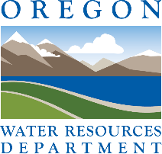
Oregon Water Conditions Report

March 10th, 2025
HIGHLIGHTS
According to the US Drought Monitor, Oregon is free of drought conditions, with nearly 4% of the state experiencing abnormally dry conditions.
Snow water equivalent (SWE)is currently measuring above the historical median for most of the state (min = 73%, max = 176%). Statewide, SWE is 114% above the historical median. For more information see individual basin plots.
February precipitation was above normal for most of the state, most notably in southeastern Oregon. Over the last two weeks, precipitation varied but was generally above normal for the northwestern half of the state and below normal for the southwestern half of Oregon.
Temperatures in February were generally below normal statewide. Temperatures over the last two weeks have generally been above normal across much of the state ranging from 2°F to 6°F above normal. In parts of the central Cascades and eastern Oregon, temperatures ranged from 2°F to 6°F below normal.
Recent soil moisture indicators over the last two weeks show a decrease in soil moisture in western Oregon and in parts of north-central and southeastern Oregon. Indicators also show an increase in soil moisture in parts of south-central and northeastern Oregon.
The seasonal climate outlook indicates probabilities leaning towards above normal precipitation for the northwestern half of the state with equal chances of above or below normal precipitation for the rest Oregon. The outlook also indicates below normal temperatures for northern parts of Oregon with equal chances of above or below normal temperatures for the rest of the state.
Streamflow conditions in February were generally normal to above normal across most of the state. However, in parts of north-central and northeastern Oregon, conditions were below normal. Recent streamflow conditions over the last seven days were below normal in most of western Oregon and in northeastern parts of the state. Elsewhere in Oregon, conditions were generally normal to well above normal.
Reservoir storage contents in many basins continue to measure near to above average. However, projects in the Crooked, Deschutes, and Powder basins are measuring below average. See USBR (including Klamath) and USACE teacup diagrams for more information.

DROUGHT CONDITIONS

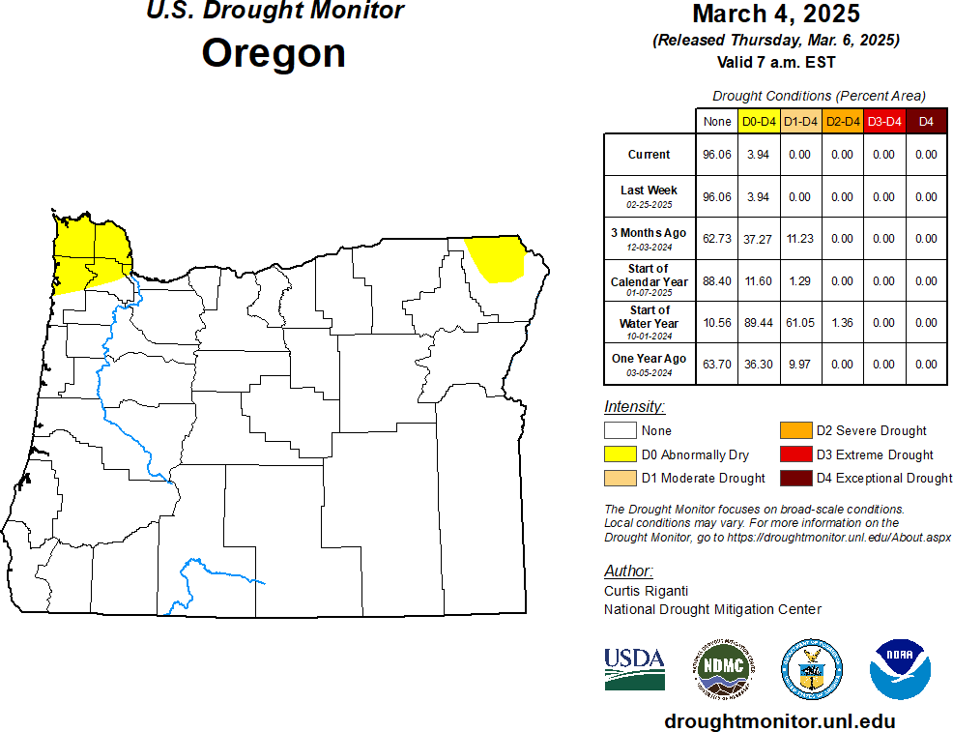

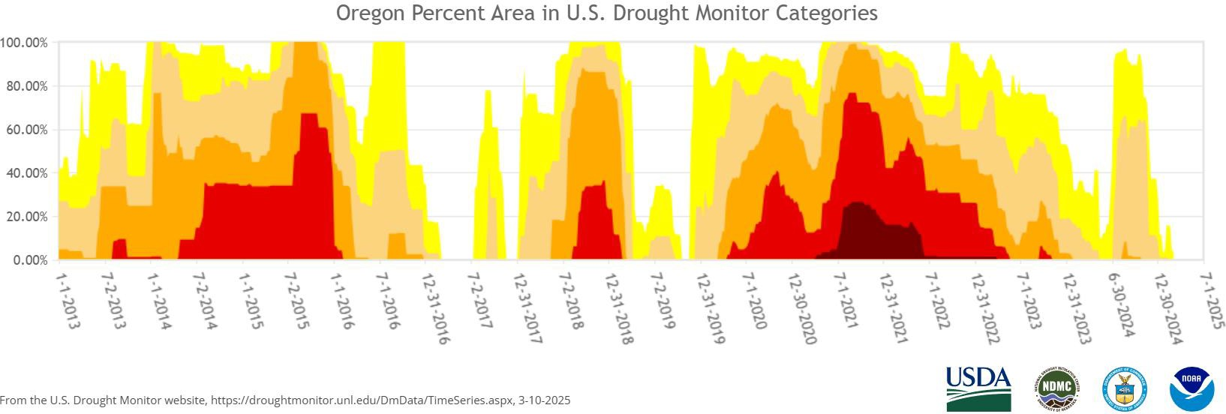

CLIMATE CONDITIONS SNOW WATER EQUIVALENT

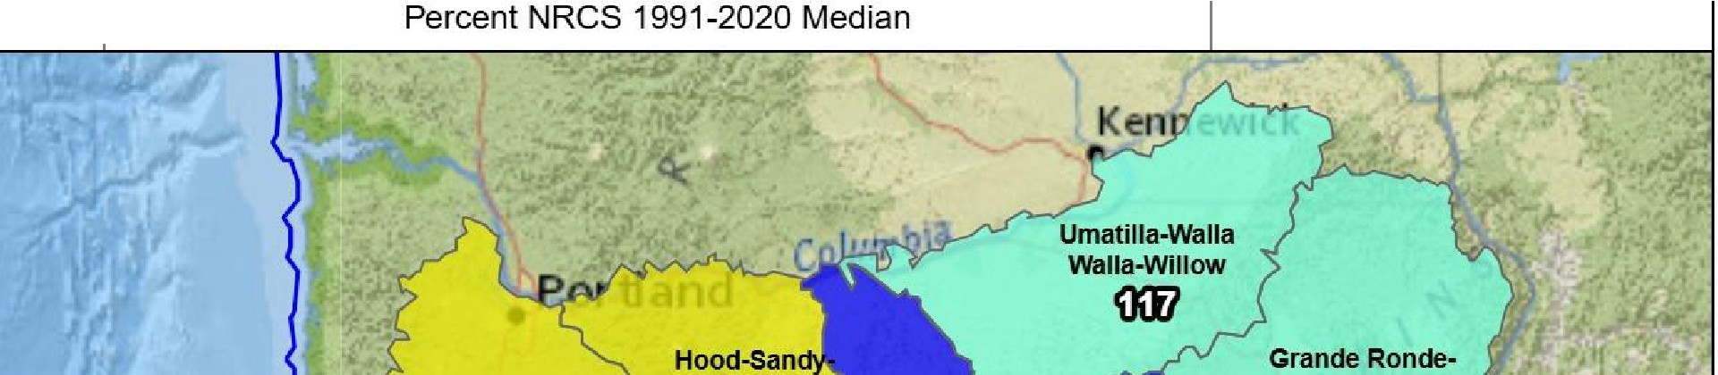
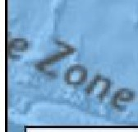
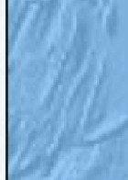
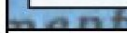
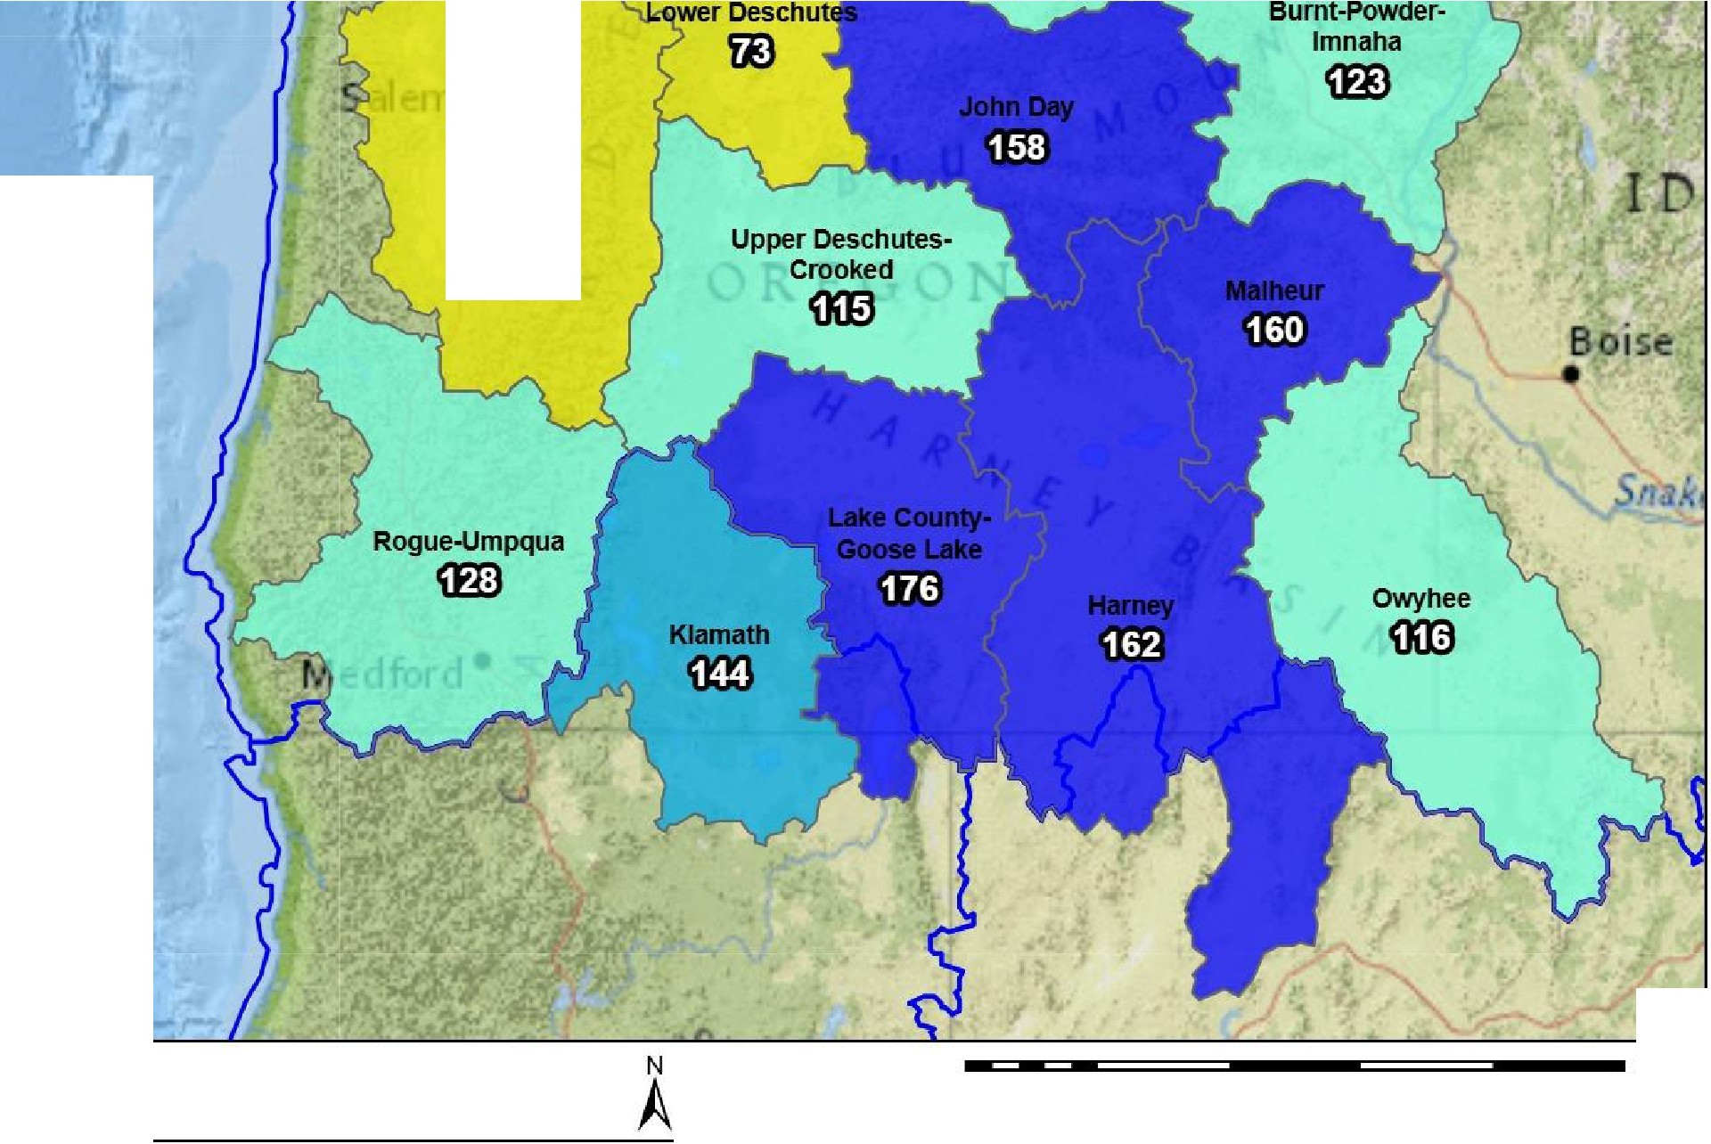
NRCS Snow Water Equivalent March 9, 2025, end of day

Snow Water Equivalent

Willamette
Elil)

Percent NRCS 1991-2020 Median
- ?.150%
(==:J 130%10149%
[==:J 110% to 129%
[==:J 90% to 109%
[==:J 70% to 89%
[==:J 50% to 69%
-<50%
[==:J No basin value
Watershed Boundarie
Region (HUC2)
- State Watersheds

USDA
-:-=

Natural Resources Conservation Service

20 40 80 120 160
Miles
200

United States Department of Agriculture
Created 3-10-2025

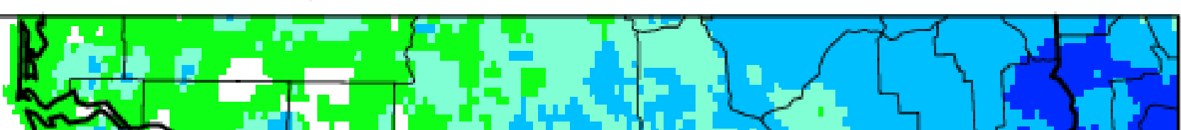
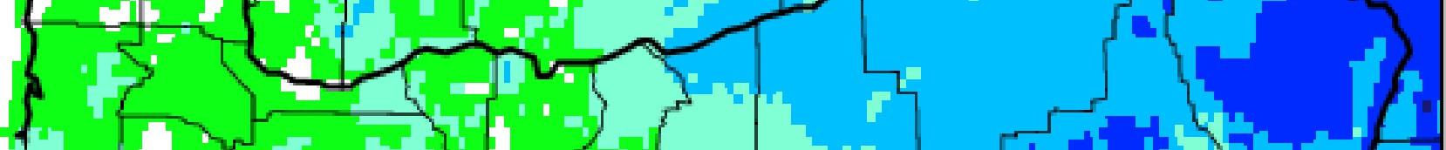
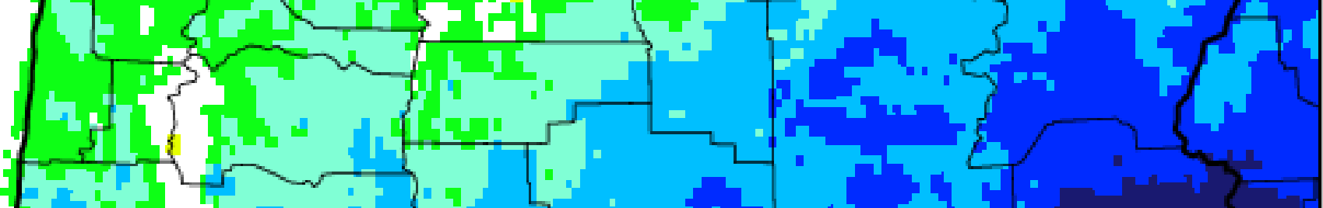
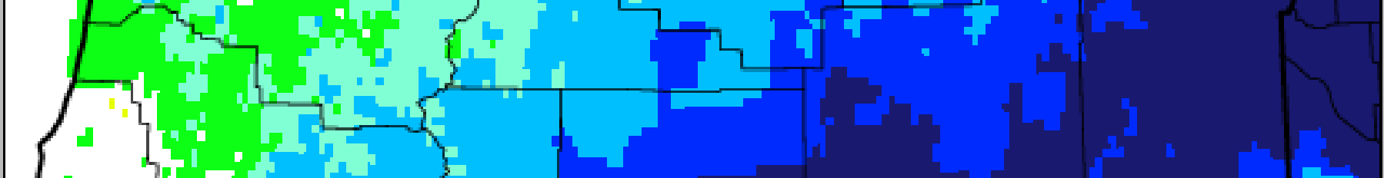
PRECIPITATION

4fl0N -

45°N -

Oregon1- P1reciiipitatio:n
Febriuary 2025 Percent o.f 1981-201O Norrmall

300,

2.00·

150

1130

1110

l

2:
-
::1:

44·•N -
100 i

z
O·
90 al
!:.

70
43°N -
50

25
4-2"N - 5
124-crw 12s.-w 122·w 1:21cw 120°w 11� rn1·w 111-w
Wes1Wide ID�,uught Tracker, U lldahoJWRCCData SourCi:l·:PAIS!M(Prelim), created 5 MAR 2025

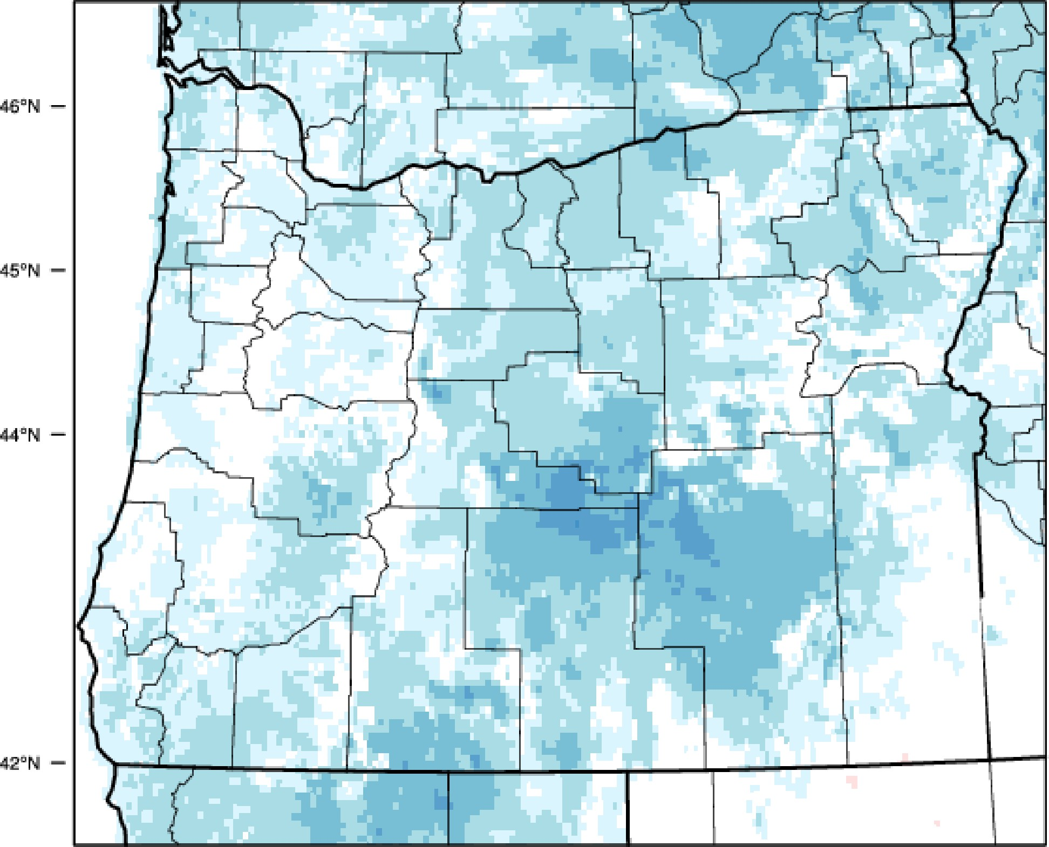


TEMPERATURE

Oregon1- Mean1Tem1peratu1re February 2025 Deparitu1re f1rom1981..2010 Nonnal

116.0
14.0
12.0
10.0

a.,o
a.,o i
"mD
4.,o ::,.
s::::
2.,0 ii
o.,o 3'
3

..2,.0 z
0
-4.0 !I
-
e.
,,illil"liilli,

43"1\1 -
-6.0
-8.0

10.C)
-12',0

14U)
�161.0
0
"T1

lN"W t23°W 122"W 121"W 120"W nsPW 118°W 1 H"W
West'Wid:e Drought lracker, U llda;ho/W1RCC IDaita So!.lrce::PRISM (IPrelim),. created 5 MAR 2025

SOIL MOISTURE

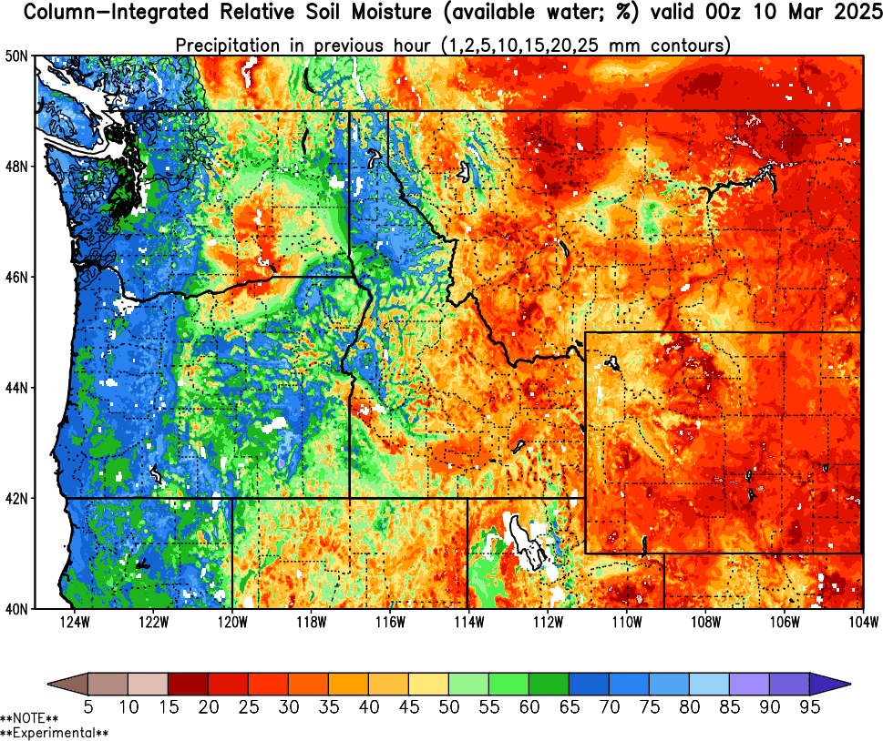

CLIMATE OUTLOOK

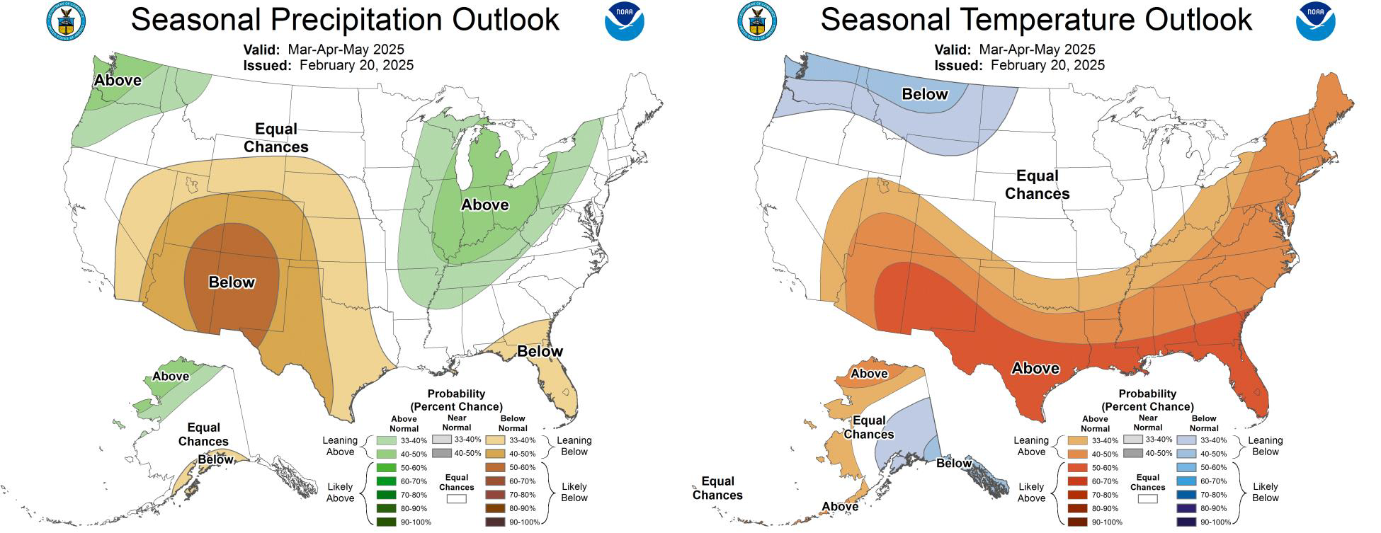

STREAMFLOW FEBRUARY

Stream Gage
e <= 30%
e | 31% - 50%
� | 51% - 70%
� | 71% - 90%
� | 91% -110%
� | 111% -130%
e | > 130%

Counties
- <= 30%
- 31%- 50%
51% - 70%
71% - 90%
91% -110%
111% - 130%
>130%

\'alo1m1

February% ofa·Average Streamdow
f Q.f: l 991-::§.P2D � -�··
l,0,-�1
- WY 2025
Kermevmil

Wall,'.IW�la

�Lake
209%
Malheur 118%

E l,IOUN"T tJS
3055,i �11•1o

s
�
..

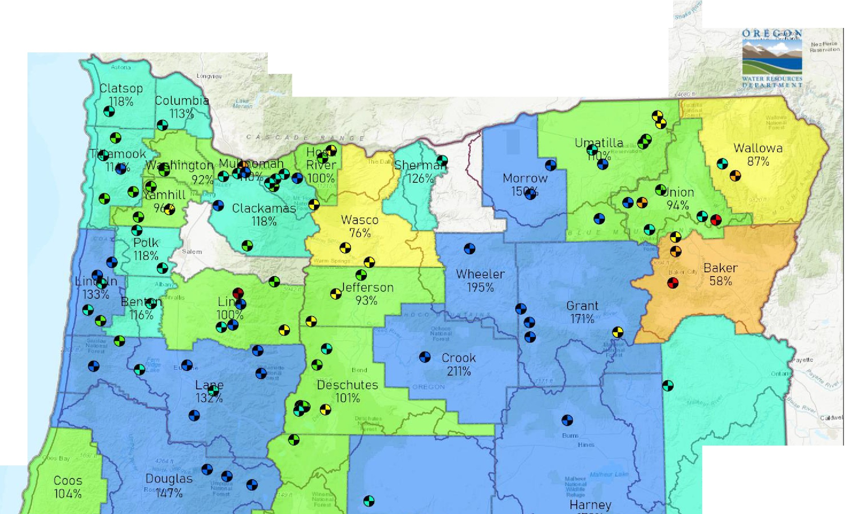
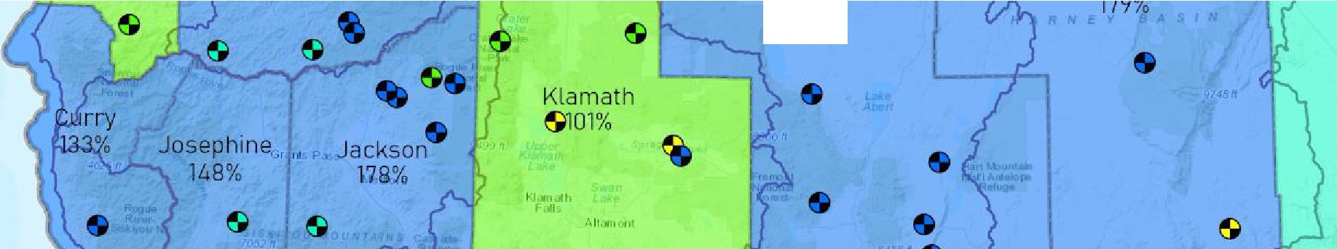
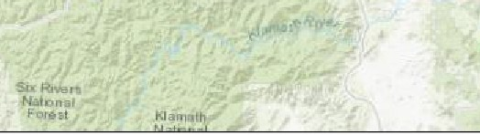

Date: 3/1012025
����-���---��-��-�--�--� 0
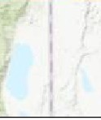
,.1,u,!r:

STREAMFLOW
7-DAY AVERAGE

'fak1m<)
7-Day % of Average Streamflow - thru March 9, 2025
0-POR: 19S£J,a-2020

,OREGON
H,1:z:P,...a
Ft,•ni111 n

Stream Gage
•
833( ff �rJ 14t��'ll.=o
R11•11
11

,� • IV"

Kenoo.,...ick

<= 30%
•
31% - 50%
s 51% - 70%
s 71% - 90%
s 91% - 110%
s 111% - 130%
e , 130%
D Counties
� OWRD Basin

owY

B A
•

E r.t01,OOA11-S
805.5� 8,<lf

Swa,
Kl.amtith L >li:it
F.ills.

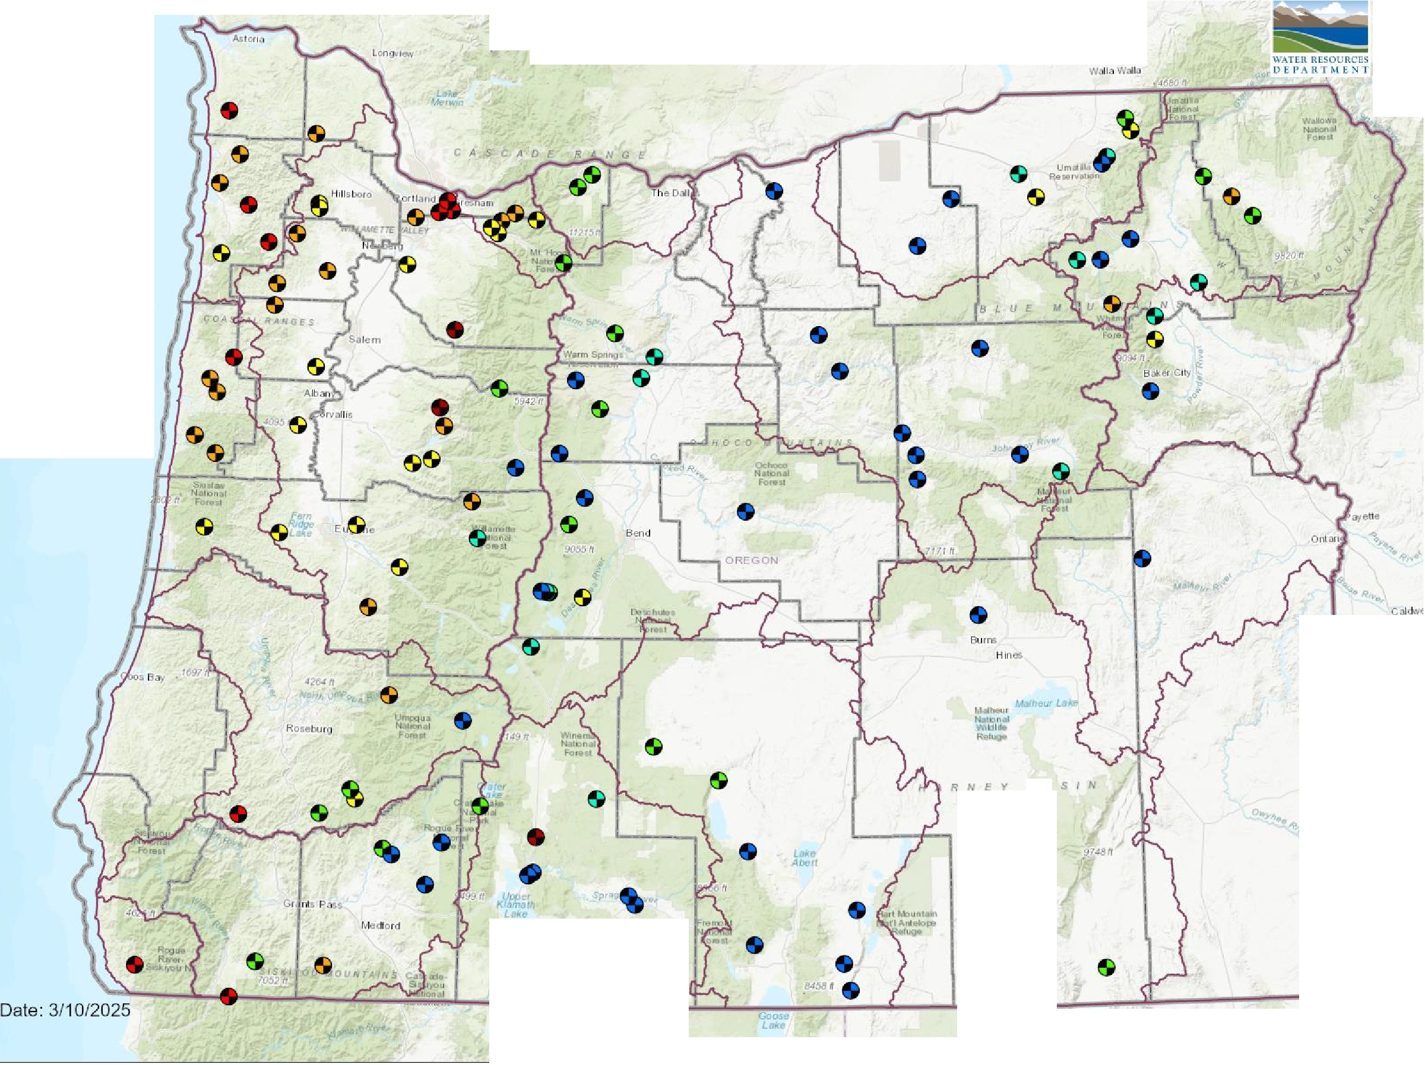
Alloo1onl
.......
"""'�
N.a.troNII

STORAGE

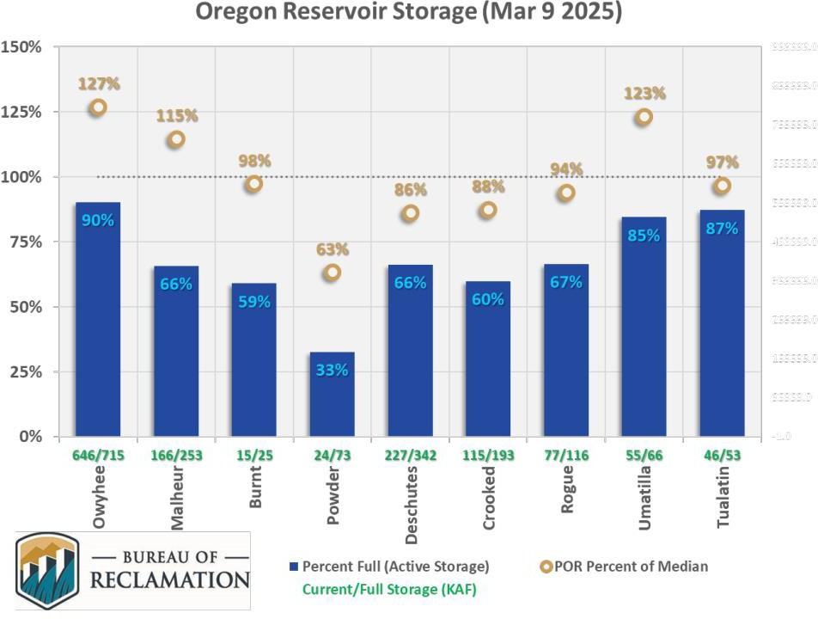

RESOURCES/REFERENCES
Please visit Oregon Water Resources Department’s drought information page to learn about current drought conditions, assistance programs, and potential drought tools.
If you are interested in submitting local drought-related conditions and impacts, please visit the drought impacts toolkit to learn more. Click here to visit the map of condition monitoring observer reports.
Released every Thursday, the US Drought Monitor provides a weekly assessment of drought conditions. The USDM provides a network infographic which depicts the network of observers who gather and report information about conditions and drought impacts.
The WestWide Drought Tracker uses data from PRISM to provide easy access to fine-scale drought monitoring and climate products, such as the figures depicting climate conditions within this report.
The National Weather Service’s Climate Prediction Center offers weekly, monthly, and seasonal climate outlooks illustrating the probabilities of temperatures and precipitation.
The Regional Climate Centers (RCC) working with NOAA partners, deliver climate services at national, regional, and state levels. Climate anomaly maps of Oregon are updated daily at around noon PST.
NASA’s Gravity Recovery and Climate Experiment (GRACE) provide satellite-based observations of soil moisture conditions that are useful as drought indicators, helpful in describing current wet or dry soil conditions.
USGS Water Watch provides maps of real-time and average streamflow conditions at USGS sites throughout the state.
Reservoir storage “teacup” diagrams are offered by both the US Bureau of Reclamation and US Army Corps of Engineers. The diagrams represent the level of fill in the reservoirs as both percent full and as a ratio of volume of water currently in the reservoir to the volume of water in the reservoir when it is full.
Oregon wildfire information can be found through InciWeb and the Oregon Department of Forestry’s Wildfire News, along with the National Interagency Fire Center which offers outlooks on the significant wildland fire potential.
Oregon Office of Emergency Management maintains a hydrology/meteorology dashboard which shows state and local drought declarations, as well as hosts many of the data sources to generate this report. Use the selection arrows at the bottom of your browser to navigate through the various sources.
US Department of Agriculture provides the Weekly Weather and Crop Bulletin as a vital source of information on US and global weather, climate, and agricultural developments, along with seasonally appropriate agrometeorological charts and tables. USDA’s Drought Programs and Assistance offers links to programs and resources to help those struggling with persistent drought.

11

