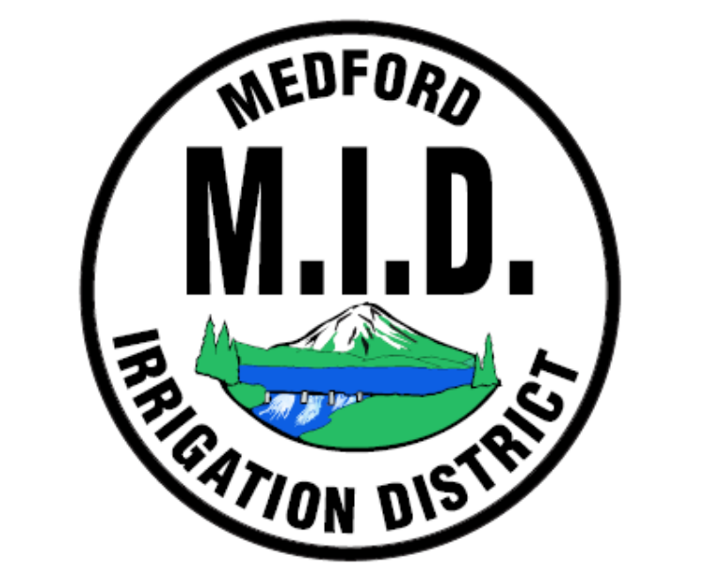
Medford Irrigation District
Jack Friend – District Manager
Tammi Flanakin – Office Manager
Board of Directors
Div 1 Dennis O’Donoghue
Div 2 Sean Naumes
Div 3 Joe DeMaggio
Div 4 Matthew Borman
Div 5 Tom Brookins
5045 Jacksonville Hwy
Central Point, OR 97502
Mailing: PO Box 70, Jacksonville, OR 97530
Office (541)899-9913 Fax (541)899-9968

MEDFORD IRRIGATION DISTRICT
NOTICE OF 2026 BUDGET AND RATE UPDATE
Dear MID Patron,
This notice provides an update and explanation of the Medford Irrigation District’s (MID) 2026 budget. Whether you have been with us for many years or have recently joined the MID family, we sincerely appreciate your continued support.
In 2025, MID established a Budget Committee to review financial needs and provide recommendations regarding rate adjustments required to maintain our irrigation system and infrastructure. The committee’s findings were presented to the Board of Directors. The committee consisted of one Board Member and one patron from each of MID’s five divisions, representing a diverse group of small- and large-acreage landowners with varying needs.
The Board of Directors carefully considered these recommendations. The decision to adjust rates was not made lightly and is necessary to ensure MID can continue providing reliable service. These changes will help retain qualified personnel, maintain equipment and infrastructure in good working condition, and allow MID to adapt to changing political and environmental conditions.
Effective January 1, 2026, the rates will be as follows:
- $97.00 per acre
- $179.00 account charge
- $24.00 special assessment per account (no change)
We understand that rate changes can be challenging and sincerely regret any hardship this may cause. Payment plans are available for patrons on fixed incomes or tight budgets.
MID remains committed to keeping increases as minimal as possible. If you have questions or would like to discuss payment options, please contact our office at (541) 899-9913.
Thank you for your continued support of the Medford Irrigation District. Your patronage is greatly appreciated, and we value the opportunity to serve you.
Sincerely,
Medford Irrigation District
Board of Directors and Staff

