Fourmile & Fish Lake 6-11-2024

2024 2023 2022 avg


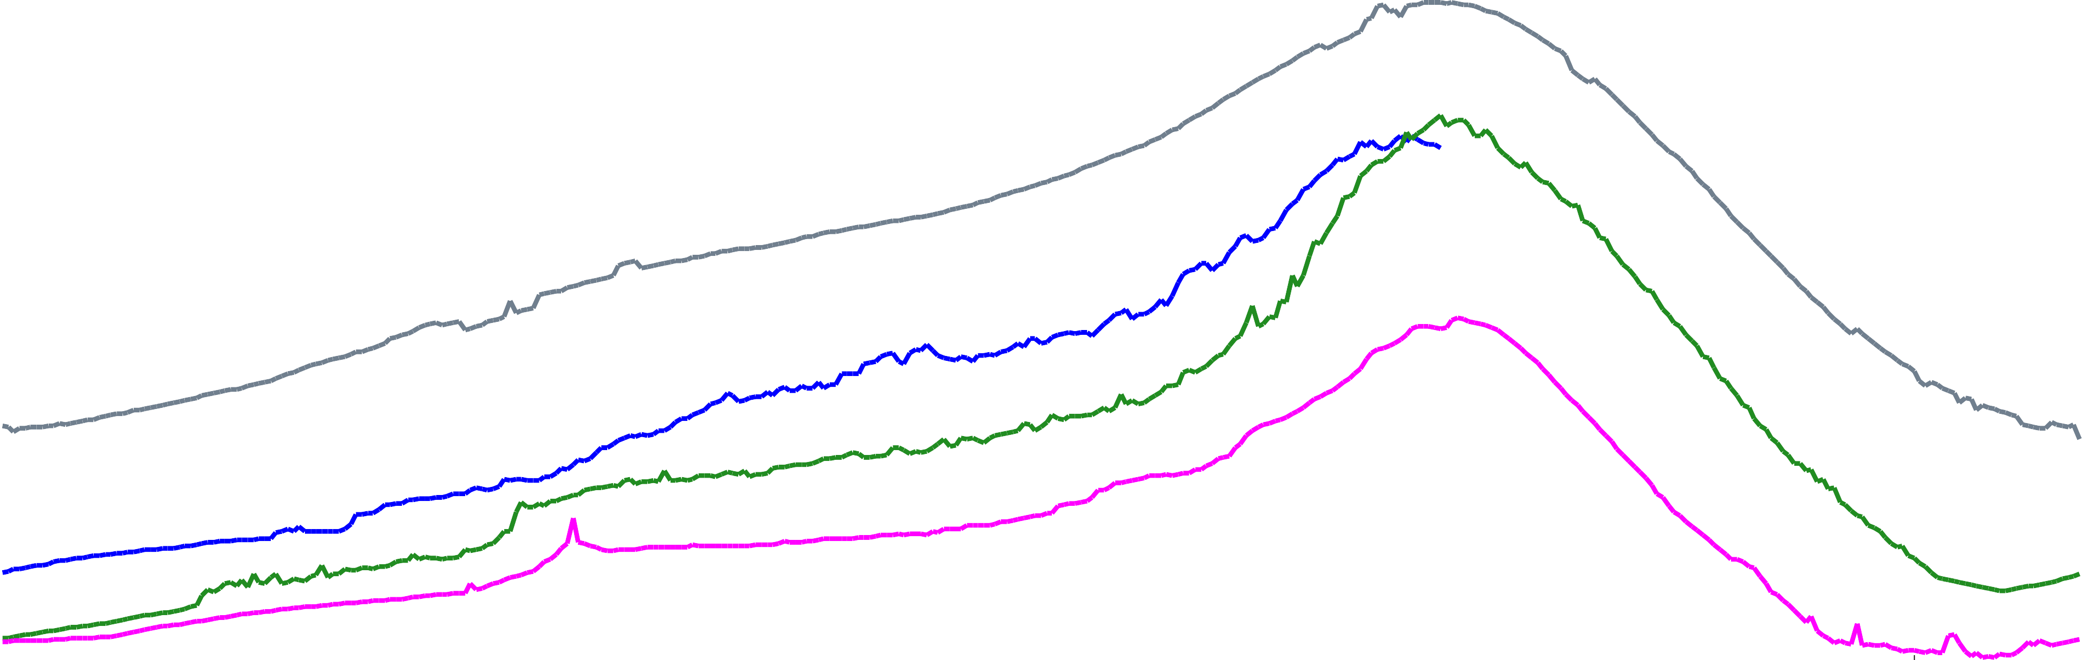
17,500
acre-feet
17,000
16,500
16,000
15,500
15,000
14,500
14,000
13,500
13,000
12,500
12,000
11,500
11,000
10,500
10,000
9,500
9,000
8,500
8,000
7,500
7,000
6,500
6,000
5,500
5,000
4,500
4,000
3,500
3,000
2,500
Oct 1

Nov 1

Dec 1

Jan 1

Feb 1

Mar 1

Apr 1

May 1

Jun 1

Jul 1

Aug 1

Sep 1

