Medford Irrigation District Floating Solar

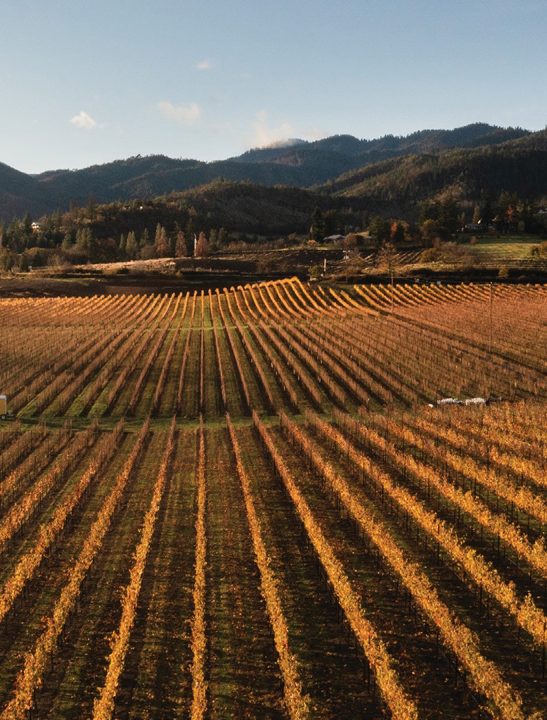
IRRIGATION COMMUNITY Medford Irrigation District LOCATION Jackson County, OR PROJECT COST $2.4M
YEAR COMPLETED Expected 2024

OVERVIEW
This community solar project will provide low-cost, locally produced, renewable energy in Southern Oregon. The project, which will be installed on a reregulation reservoir owned by Medford Irrigation District, will be Oregon’s first floating solar installation. The 0.9 MW project will generate an estimated 2 million kWh of electricity each year. Under Oregon’s Community Solar Program, 40% of that energy will be offered to local businesses, and 60% to Jackson County residents and at least 30% to low-income community members. When complete, the floating solar panels will also reduce evaporation from the reservoir while reducing the growth of algae and aquatic weeds, improving water supply reliability for agriculture.

PROJECTED BENEFITS

BEFORE AFTER

Reservoir evaporation reduces agricultural water supplies, and algal growth contributes to increased operations costs and decreased agricultural water quality
- Reduced reservoir evaporation, reduced algal growth, reduced operations costs, and improved water quality

Irrigation districts, agricultural producers, and the surrounding community purchase
market-rate electricity
  - Low-cost, locally produced, renewable energy offered to local businesses (40% of energy generated), Jackson County residents (60% of energy generated) and low-income community members (at least 30% of energy generated)
  - Up to a 50% reduction in electric utility bills for project subscribers
  - 100 low-income homes powered with low-cost, locally produced, renewable energy

Limited revenue sources for irrigation district operations
    - Approximately $46,000 in annual revenue from energy generation to support irrigation district operations

