Fourmile and Fish Lake Combined Storage

2002 2003 2004 2005 2006 2007 2008 2009 2010 2011 2012 2013 2014 2015 2016 2017 2018 2019 2020
2021 2022 avg

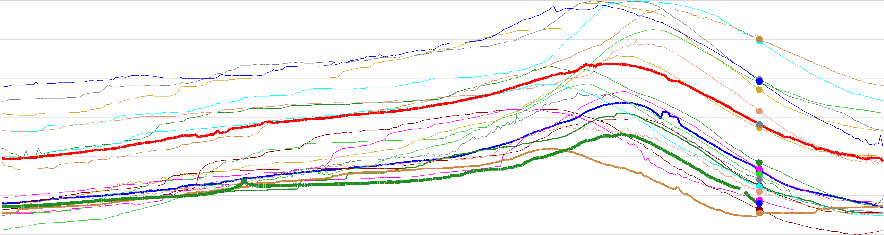
24,000

22,000

20,000

18,000

16,000

14,000

12,000

10,000

8,000

6,000

4,000

2,000

0

Oct 1
acre-feet
Nov 1
Dec 1
Jan 1
Feb 1
Mar 1
Apr 1
May 1
Jun 1
Jul 1
Aug 1
Sep 1

