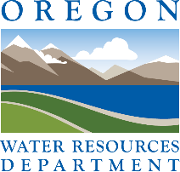
Oregon Water Conditions Report

March 24th, 2026

HIGHLIGHTS
According to the US Drought Monitor, over 41% of Oregon is experiencing moderate (D1) to severe drought (D2). Over the last two weeks, drought conditions have expanded across much of the state.
Snow water equivalent (SWE) in basins across the state is currently measuring well below the historical median (min = 0%; max = 39%).
Statewide, SWE is 18% of the historical median.
Over the past two weeks, precipitation across most of Oregon was below normal, on the order of 1.5 inches below normal. Southwestern Oregon recorded the largest deficits at 1.5 to 4.5 inches below normal. In parts of northwestern and northeastern Oregon, above-normal precipitation was recorded, with up to 3 inches above normal in northwestern Oregon.
Temperatures over the past two weeks were above normal statewide. For much of southern and central Oregon, temperatures were 5°F to 10°F above normal.
Recent soil moisture indicators show drier-than-normal conditions across much of western Oregon and in northeastern parts of the state. Elsewhere, conditions are generally near normal with scattered areas of drier-than-normal and wetter-than-normal conditions.
The near-term climate outlook indicates probabilities leaning towards above-normal precipitation for most of Oregon, with near-normal precipitation for some of northwestern Oregon. The outlook also indicates near-normal temperatures statewide.
Recent streamflow conditions over the last seven days have been below normal across much of Oregon. Most notably, in southern and eastern regions of the state, conditions were generally below to well below normal. For portions of the Cascade Range, Blue Mountains, and Wallowa Mountains, streamflow conditions were normal to above normal. Water year–to-date (WYTD) streamflow conditions have been below normal for most of the state. However, WYTD conditions for basins in south-central and in subregions of northeastern and northwestern Oregon have been near normal.
Reservoir storage in many basins is near to above normal. However, projects in the Burnt and Umatilla basins are measuring below normal. See USBR (including Klamath) and USACE teacup diagrams for more information.

DROUGHT CONDITIONS

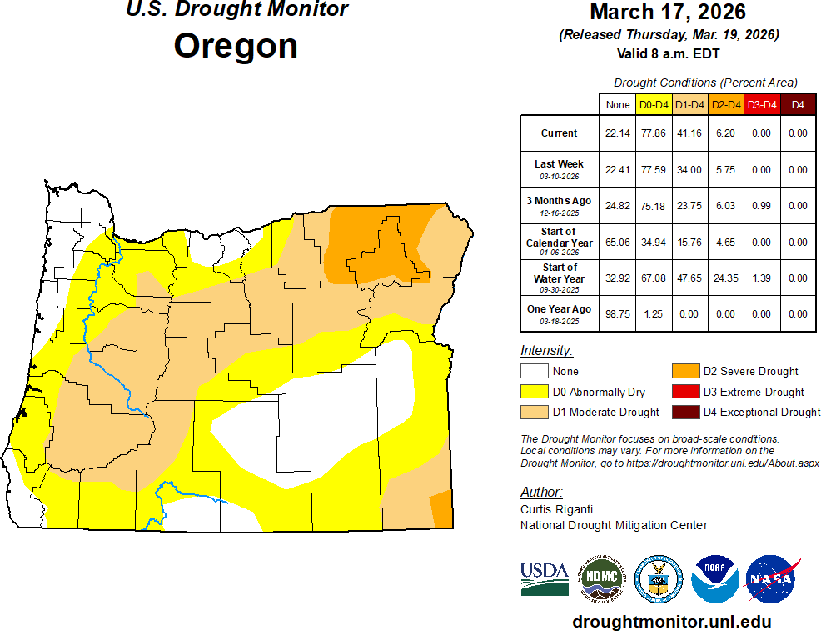

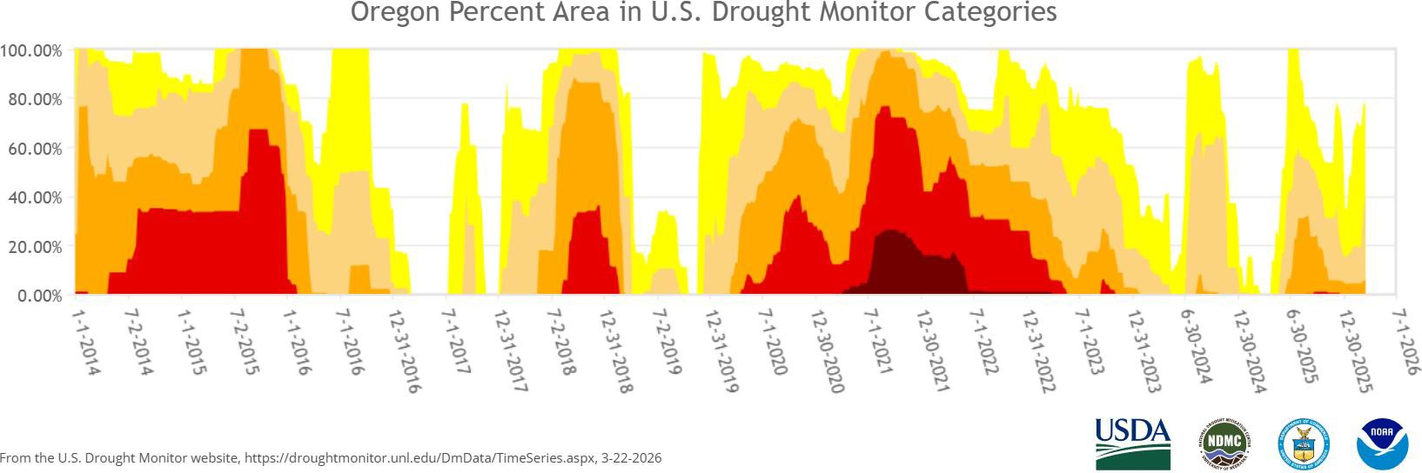

CLIMATE CONDITIONS SNOW WATER EQUIVALENT
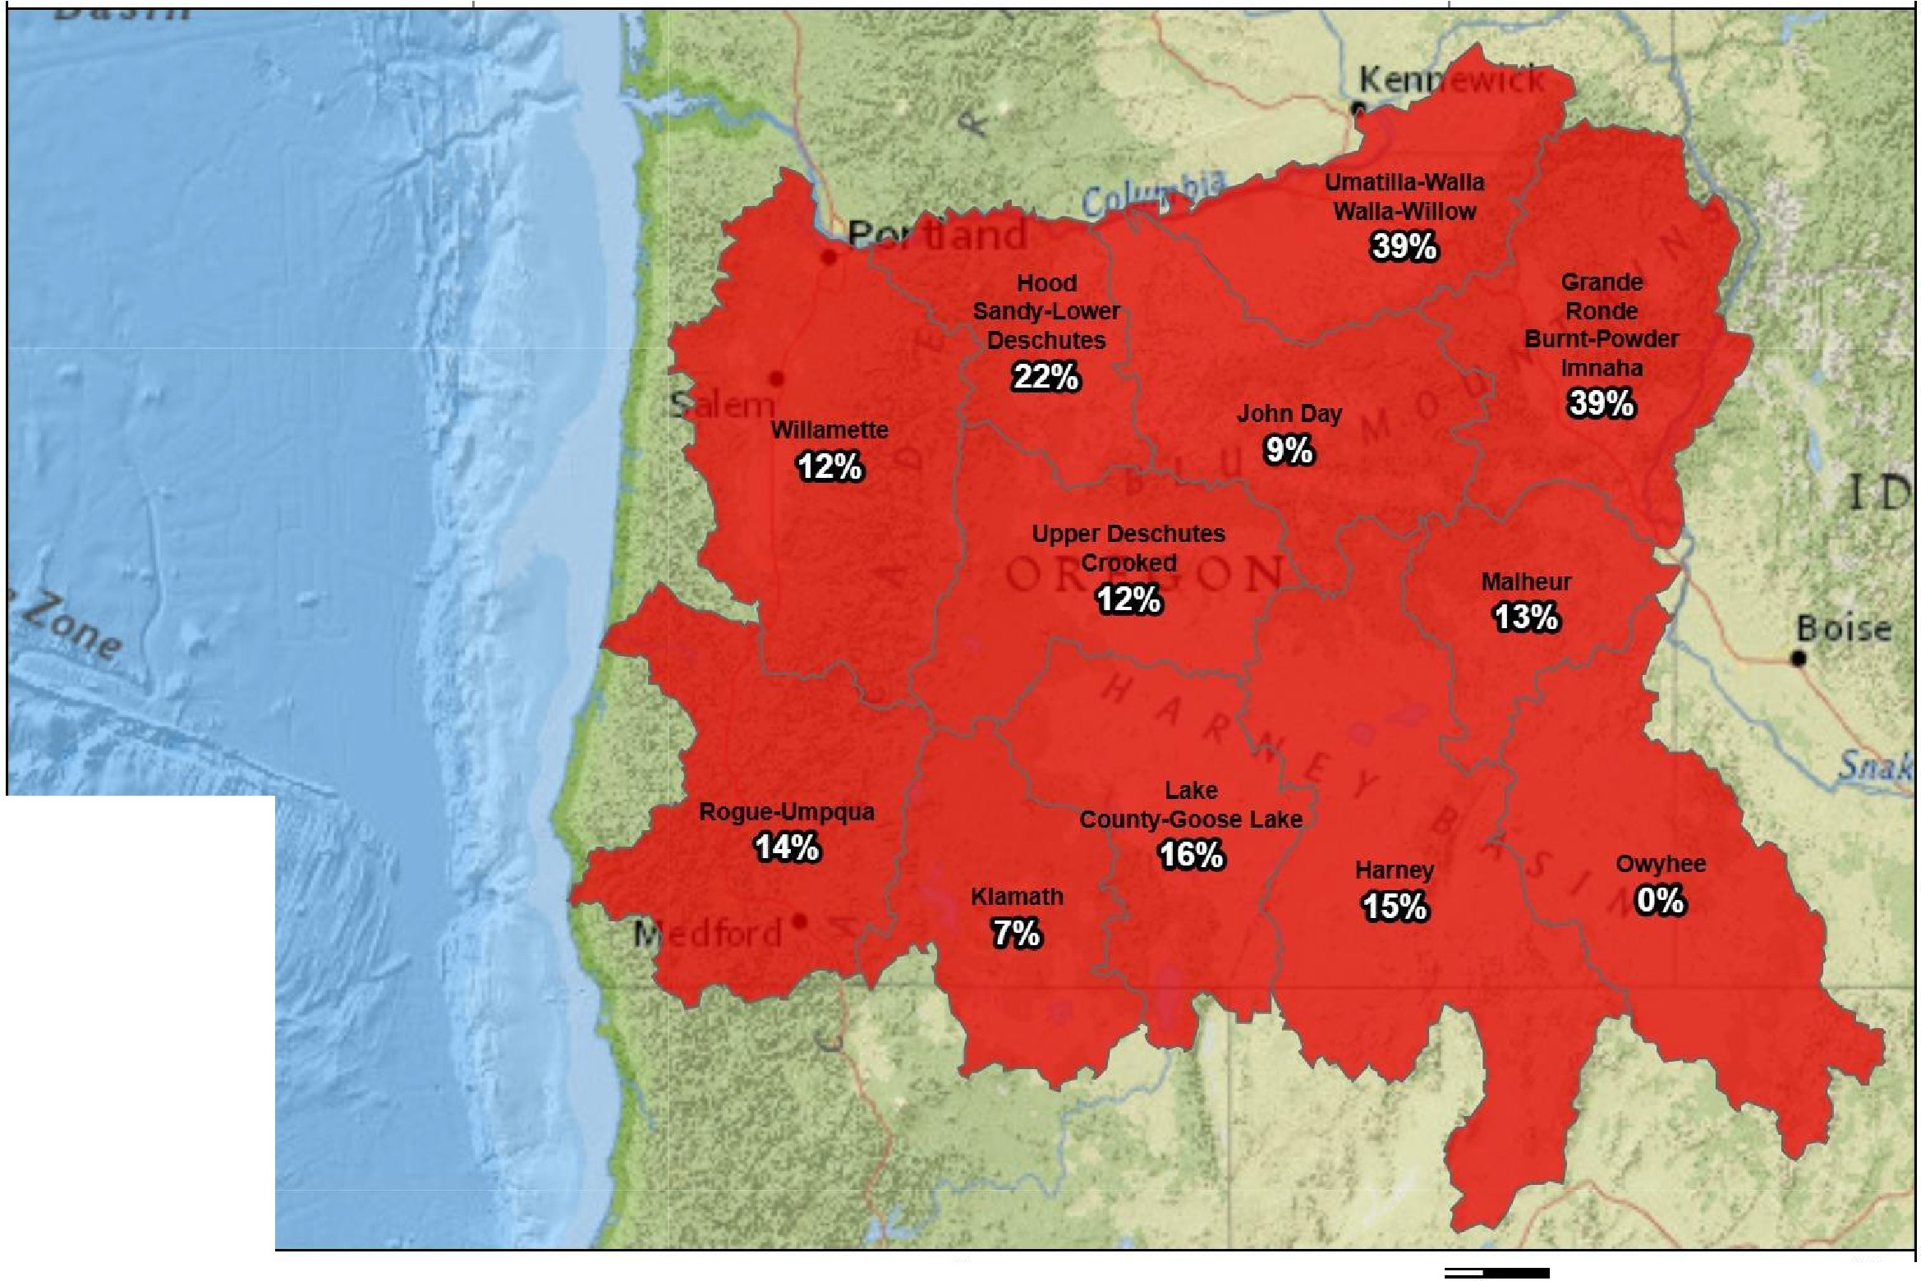
Snow Water Equivalent
NRCS Snow Water Equivalent
Percent NRCS 1991-2020 Median
March 23, 2026, end of day
,
USDA Natural Resources
--,--
Conser.1ation Service
United States Department or Agriculture
A
N
0 20 40
80
120
160
Miles 200
Created 3-24-2026
Percent NRC s 1991-2020 Median
-2150%
CJ130% to 149%
CJ 110% to 129%
CJ 90% to 109%
CJ 70%1089%
CJ 50% lo 69%
-<50%
CJNo basin value
Watershed Boundarie�
- State Watersheds

PRECIPITATION

Oregon Contours

Total Precipitation Percent of Normal (March 10, 2026 - March 23, 2026)

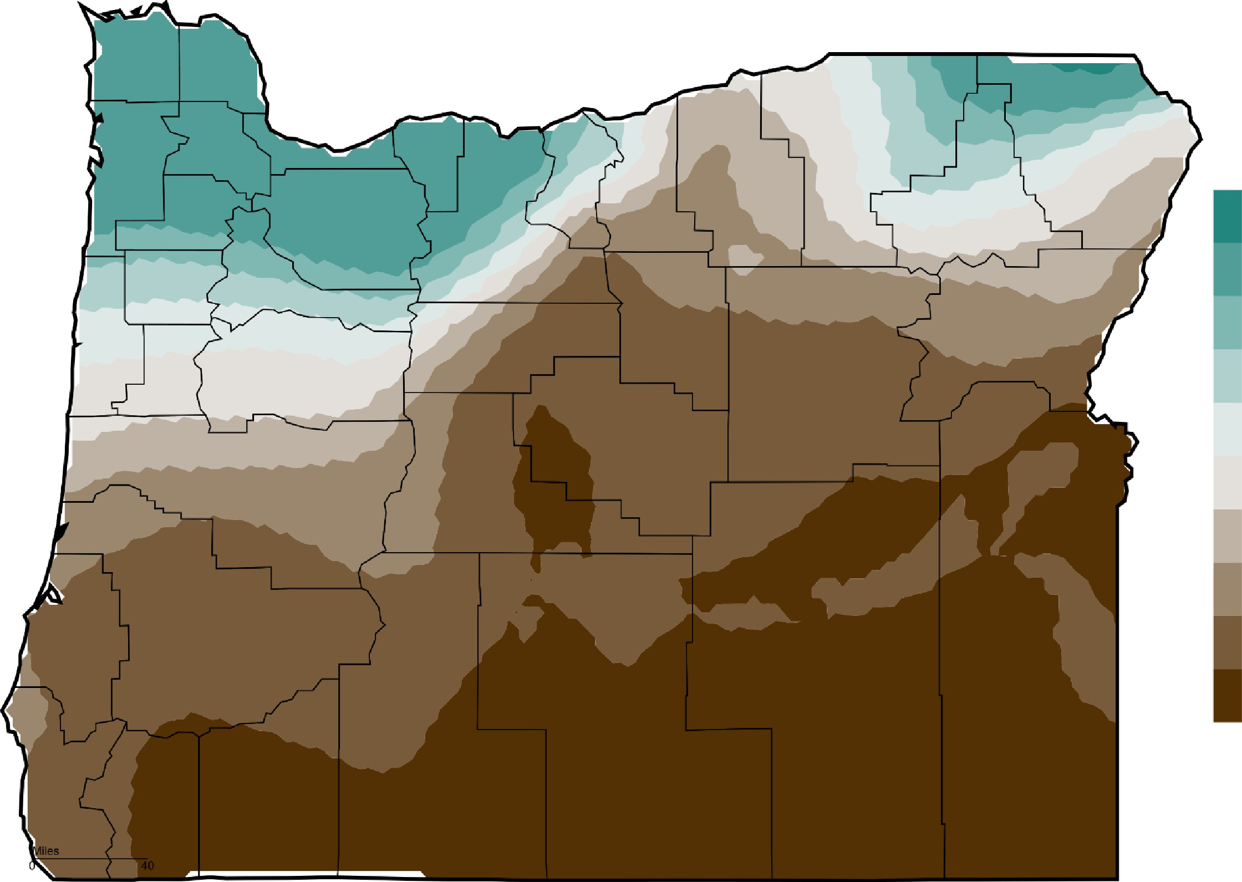
'2f2-

.A.300

200
150
130
110
90
70
50
25
5
0
-
0

z
0-,

3
ru

Western Regional Climate Center/ High Plains Regional Climate Center

TEMPERATURE

Oregon Contours
Mean Temperature Departure from Normal (March 10, 2026 - March 23, 2026)

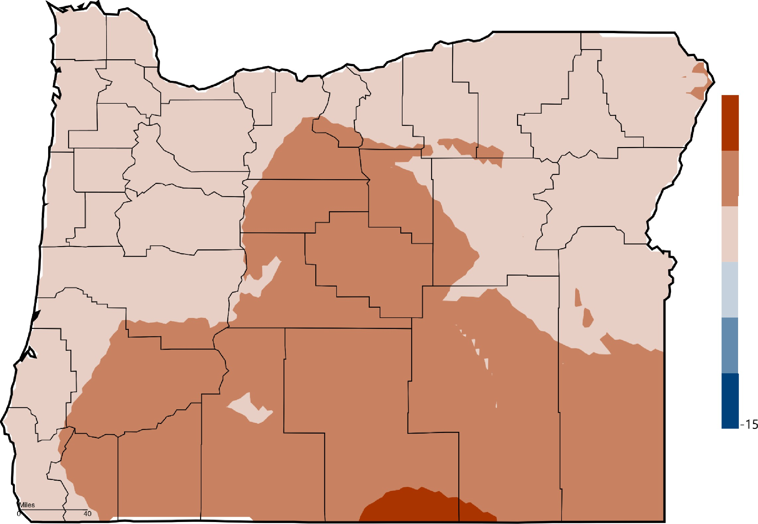
0
15
10
5
0
-5
-10
-
"T'1
'0
3

z
0
'3
ru

Western Regional Climate Center I High Plains Regional Climate Center

SOIL MOISTURE

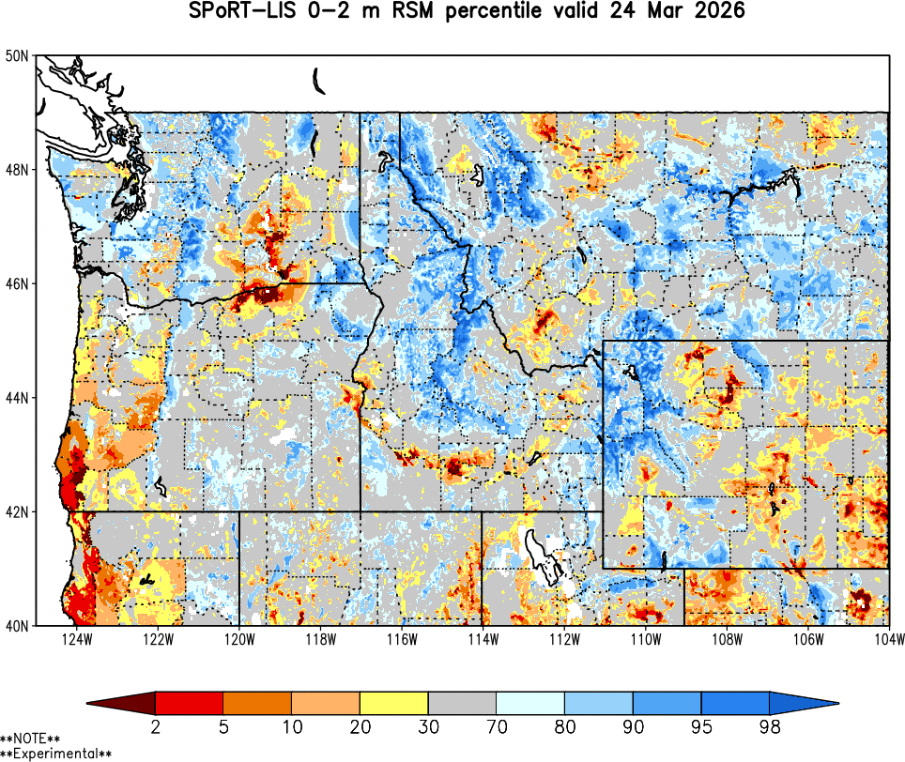

CLIMATE OUTLOOK
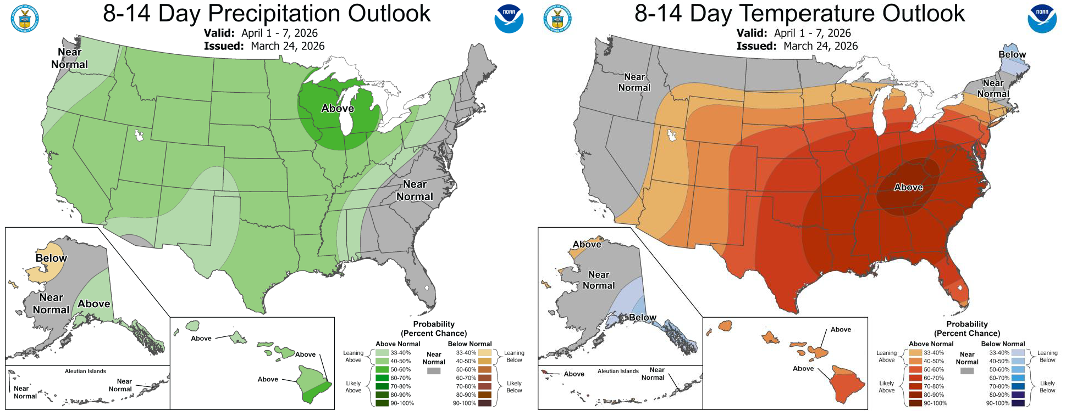

STREAMFLOW
7-DAY AVERAGE

Stream Gage
1
e <= 30%
e 31% - 50%
S 51%- 70%
S 71% - 90%
S 91% -110%
S 111% - 130%
e > 130%
D Counties
� OWRD Basin

•011..,.
7-Day % of Average Streamflow'··_thru March 23, 2026'"···
,,,.,PQR: 19�1--2020
,,.�,.p..val
81Jof!
f'.ltlw>t HMi.>n
N6't Rta,v.i,on Kennew1d!

0 REGO N

N-:tP_,U
R,a..,,,,.,10n

"'1.alto.ur M
N.lton.i W1Hl't
""'-

owY
.E l,IOll,..fAIJwS
�� 8-ffl

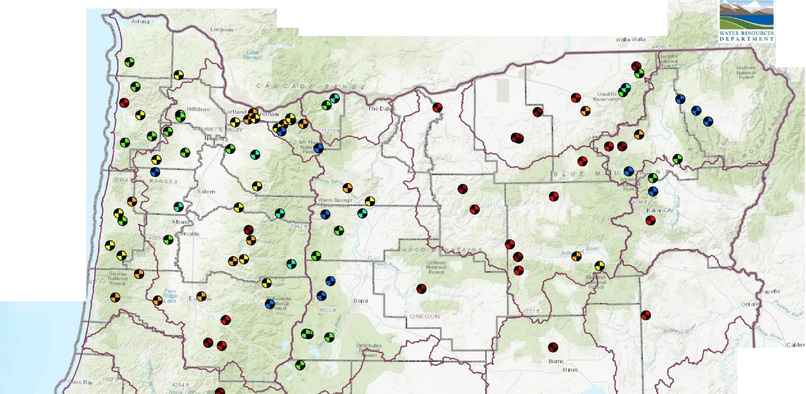
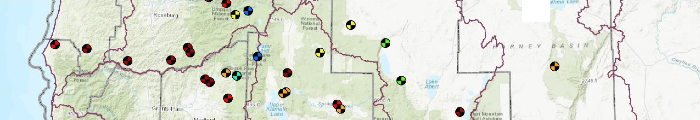

SWdl'
Kl::.nDl:h l ke
Folls
AltYl'IOfll

WATER YEAR-TO-DATE
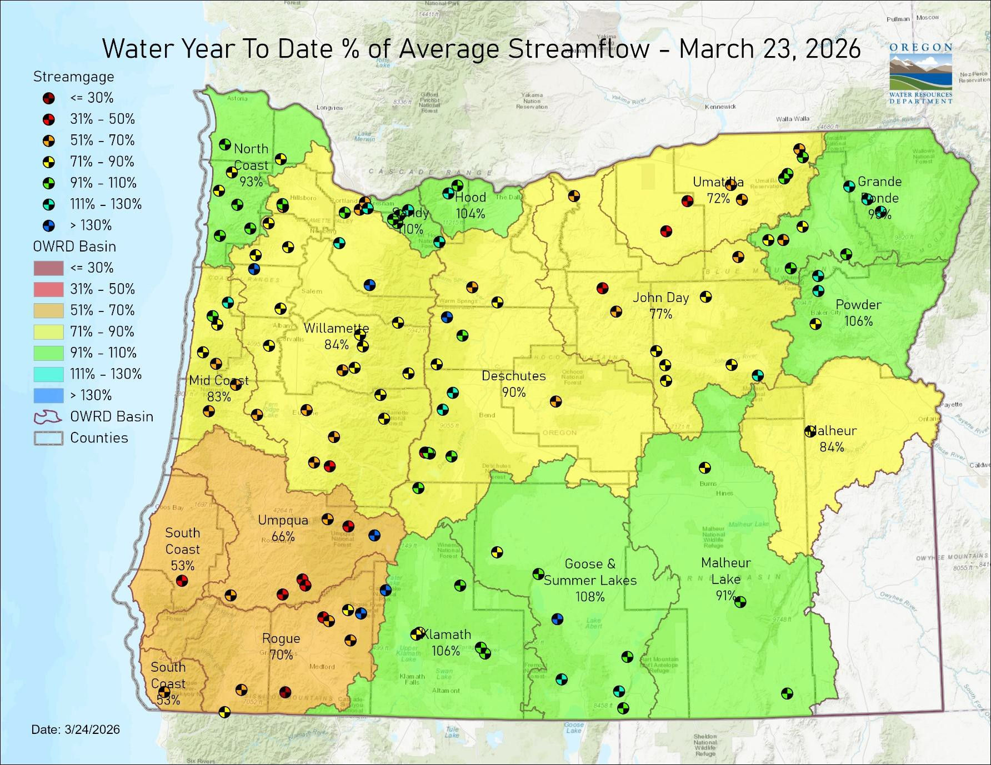

STORAGE
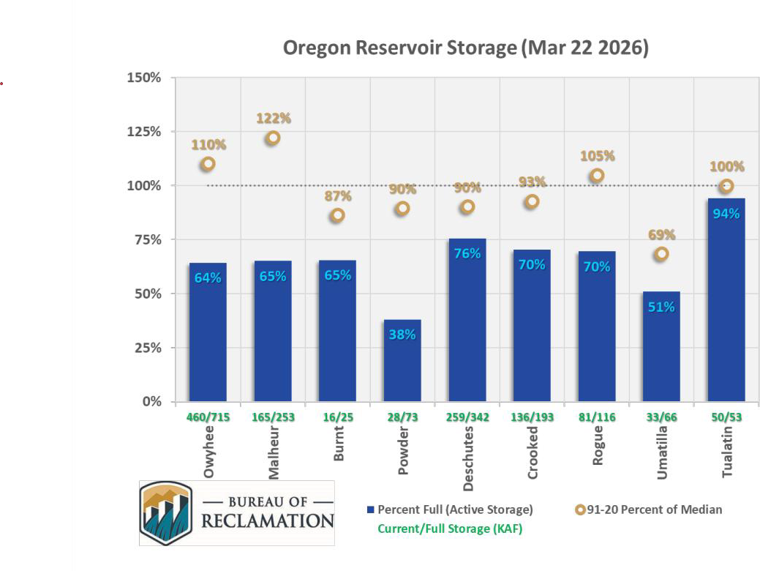

RESOURCES/REFERENCES
Please visit Oregon Water Resources Department’s drought information page to learn about current drought conditions, assistance programs, and potential drought tools.
If you are interested in submitting local drought-related conditions and impacts, please visit the drought impacts toolkit to learn more. Click here to visit the map of condition monitoring observer reports.
Released every Thursday, the US Drought Monitor provides a weekly assessment of drought conditions. The USDM provides a network infographic which depicts the network of observers who gather and report information about conditions and drought impacts.
The WestWide Drought Tracker uses data from PRISM to provide easy access to fine-scale drought monitoring and climate products, such as the figures depicting climate conditions within this report.
The National Weather Service’s Climate Prediction Center offers weekly, monthly, and seasonal climate outlooks illustrating the probabilities of temperatures and precipitation.
The Regional Climate Centers (RCC) working with NOAA partners, deliver climate services at national, regional, and state levels. Climate anomaly maps of Oregon are updated daily at around noon PST.
NASA’s Gravity Recovery and Climate Experiment (GRACE) provide satellite-based observations of soil moisture conditions that are useful as drought indicators, helpful in describing current wet or dry soil conditions.
USGS Water Watch provides maps of real-time and average streamflow conditions at USGS sites throughout the state.
Reservoir storage “teacup” diagrams are offered by both the US Bureau of Reclamation and US Army Corps of Engineers. The diagrams represent the level of fill in the reservoirs as both percent full and as a ratio of volume of water currently in the reservoir to the volume of water in the reservoir when it is full.
Oregon wildfire information can be found through InciWeb and the Oregon Department of Forestry’s Wildfire News, along with the National Interagency Fire Center which offers outlooks on the significant wildland fire potential.
Oregon Office of Emergency Management maintains a hydrology/meteorology dashboard which shows state and local drought declarations, as well as hosts many of the data sources to generate this report. Use the selection arrows at the bottom of your browser to navigate through the various sources.
US Department of Agriculture provides the Weekly Weather and Crop Bulletin as a vital source of information on US and global weather, climate, and agricultural developments, along with seasonally appropriate agrometeorological charts and tables. USDA’s Drought Programs and Assistance offers links to programs and resources to help those struggling with persistent drought.

