MID NEWSLETTER
  - 2025/2026

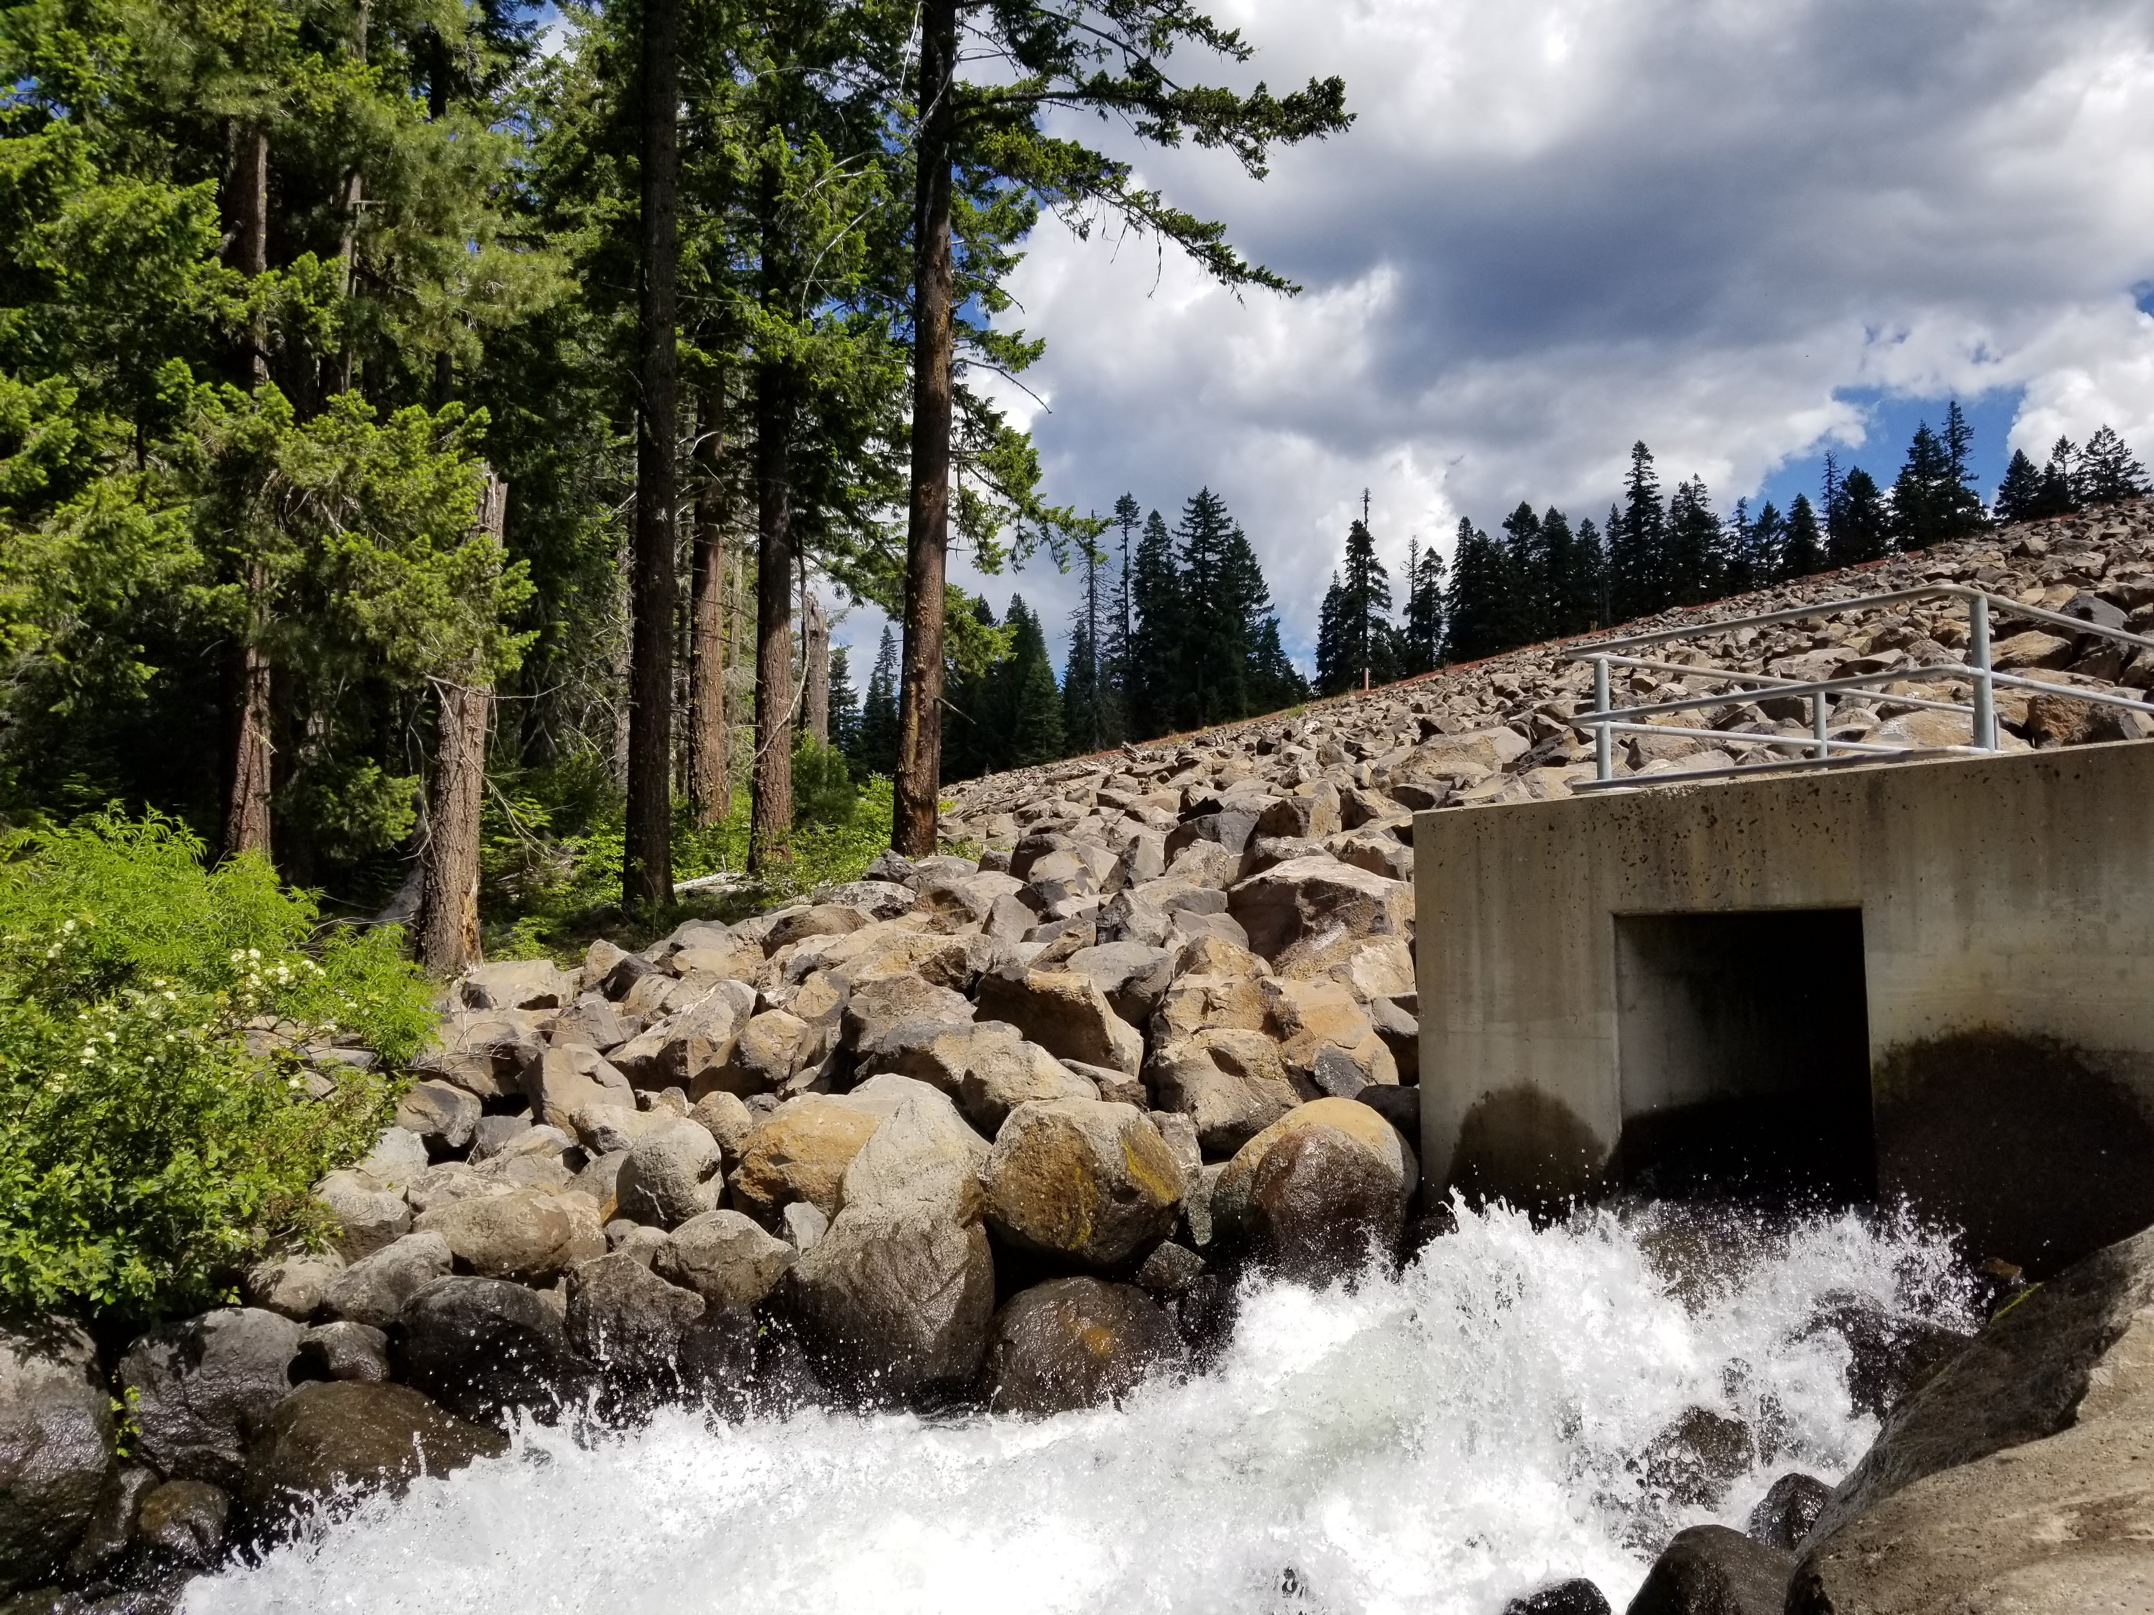  2025/2026 HOLIDAYS  MID WILL BE CLOSED:  May 26th Memorial Day  June 19th Juneteenth  July 4th Independence Day  Sept. 1st Labor Day  Oct. 13th Columbus Day  Nov. 27th – 28th Thanksgiving  Dec. 24th – 25th Christmas  Dec. 31st - Jan. 1st New Years  Feb. 17th Presidents Day  BOARD MEETINGS:  April 9th @ 5:00pm  May 14th @ 1:30pm  June 18TH @1:30pm  July 9TH @ 1:30pm  August 13TH @ 1:30pm  September 10TH @ 5:00pm  October 8TH @ 1:30pm |  | Hours of operation  MID OFFICE HOURS  APRIL thru OCTOBER  8:00 AM – 4:30 PM  NOVEMBER thru MARCH  7:30 AM – 4:00 PM | CONTACT INFORMATION  CONTACT US…  OFFICE: 541-899-9913  FAX: 541-899-9968  Website: www://medfordid.org  Email: medid@medfordid.org  Emergency Line: 541-770-0277  ___________________________  Ditch Riders:  Ride 1: Jose  Ride 2: Carlos  Ride 3: Jadd  Ride 4: Dan  Relief Riders:  Ride 1&2: Ernesto  Ride 3&4: Diego
  _________________________
  Staff:
  Manager: Jack Friend
  Office Mgr: Tammi
  Office Asst: Dusk
  Foreman: Jacob Young
  West Side Supervisor: Dan
  Maintenance Supervisor: Manuel
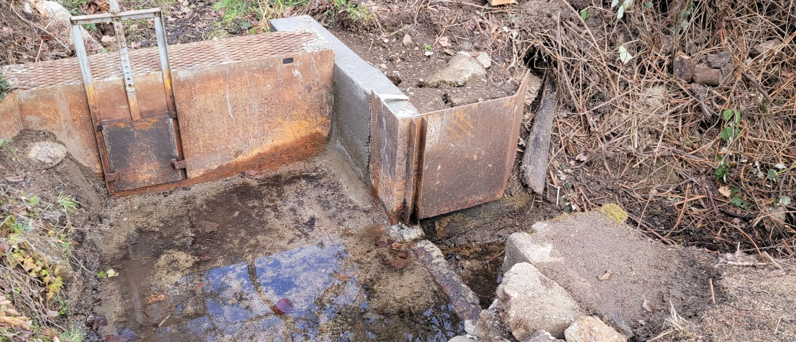 |  |  | 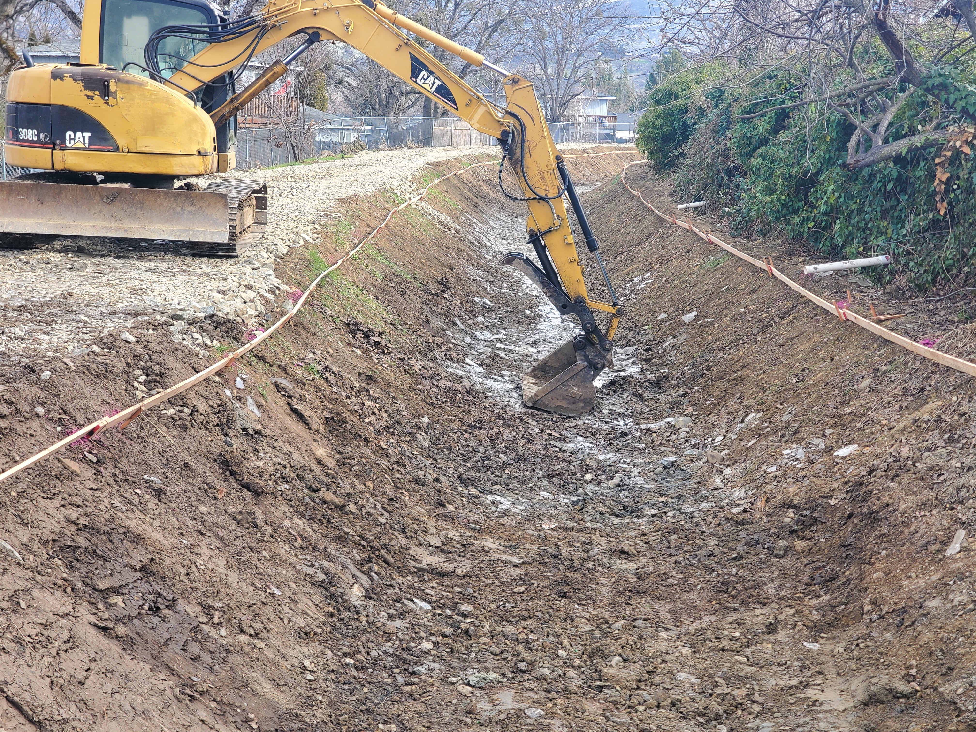
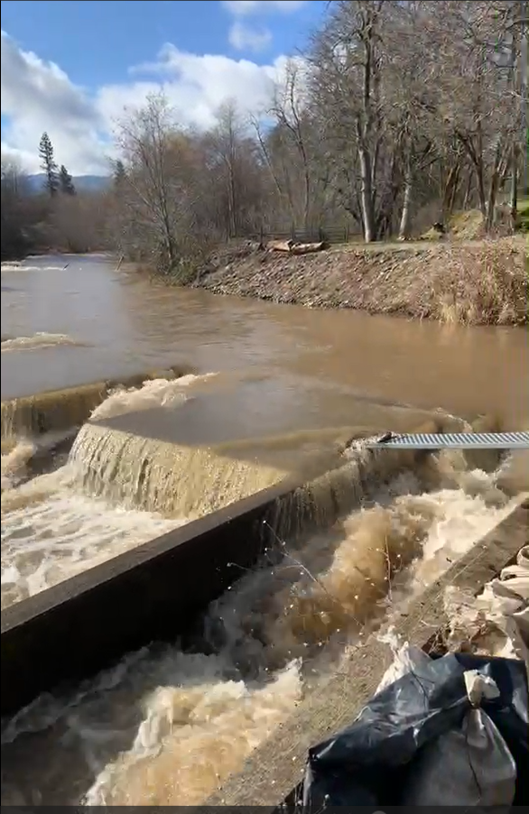  ALERT THE OFFICE IF YOU…  Sold your property, have a name change that coincides with Jackson County records, new mailing address and/or phone number, email address and/or haven’t received your annual billing.  SIGN UP FOR UPDATES ON OUR WEBSITE OR CALL OUR OFFICE AND WE CAN SIGN YOU UP.  ADDITIONALLY….  Report any violations that you may see on or around our infrastructure of canals, laterals, equipment, and theft of water as well. Working together will help make deliveries smoother and the availability of water for everyone. | Canal Safety: Waters in the canal are non-potable and for irrigation purposes only. Do not drink, swim, bathe or otherwise contact the water. It is not recommended for pet and livestock drinking. The water is fast-moving and treacherous for humans and animals. For this reason, stay away from the canal and ALWAYS keep children, pets, and farm animals away. If you see an animal in the canal, contact the district right away. Please do not attempt to remove any animal on your own.  Mission Statement  To deliver water equitably and efficiently with the least amount of cost to its water users, keeping in mind the need for long-range planning and environmental impact. Through leadership, use of technical expertise, efficient operations, responsive customer service, and the creativity of people, Medford Irrigation District will seek to protect and preserve local natural and ecosystems through the effective use of water.
 | 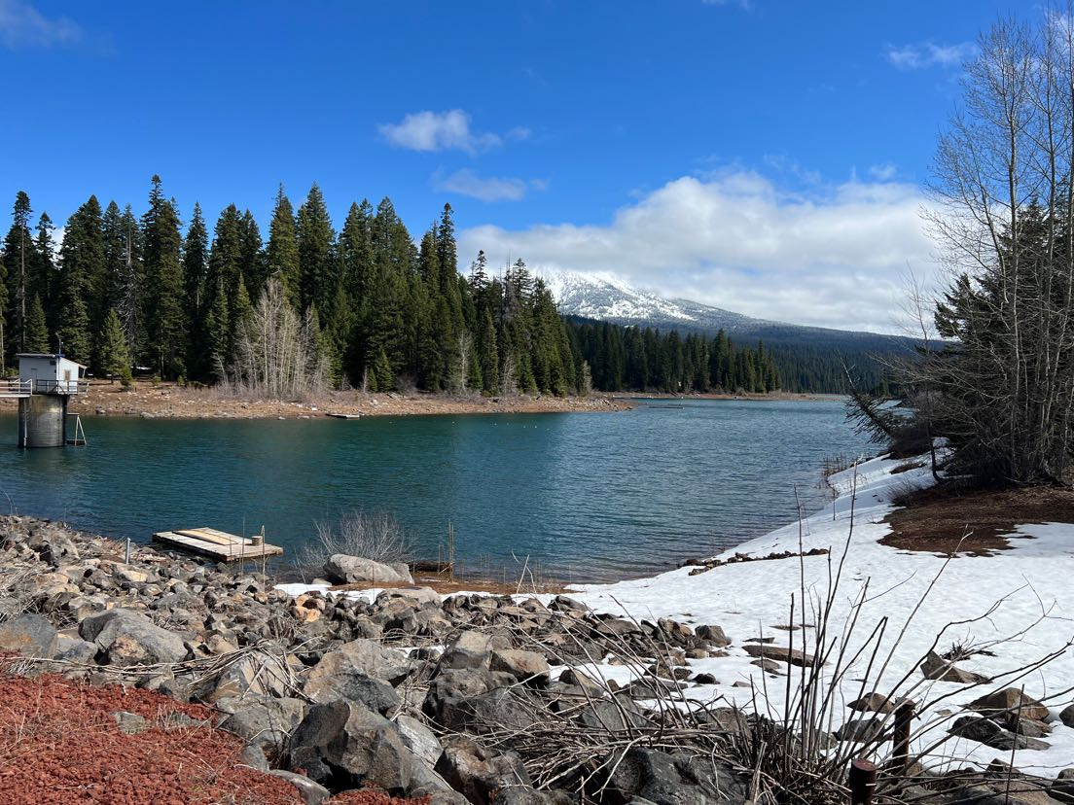
  Important Dates to Remember:  August 28th, 2025, through Oct. 7th, 2025 @ 5pm, is the nominating petition period for a new/current board member to cast their name for the open position for their division. This year’s board seats that are up for election are: Divisions 1, 2, 3, and 4.  NOTICE OF OPENINGS FOR THE BOARD OF DIRECTORS  There are 4 positions on the Board of Directors of Medford Irrigation District that will be open at the end of 2025 The open positions are for Division(s) 1, 2, 3, & 4 (currently held by Dennis O’Donoghue, Sean Naumes, Joe DeMaggio, and Matt Borman) to fill a full term of three years.  The new term of office will begin on 1 Jan 2026. Parties interested in running for election for either board position must file a Nominating Petition. To run for a board, position the candidate must be registered with Medford Irrigation District to vote in a division election, must be a qualified elector in the open division, and must file a valid Nominating Petition by 5:00 PM, Tuesday, October 7th, 2025, at the district office.  To inquire about qualifications and/or to pick up a Nominating Petition, please contact the MID office at 5045 Jacksonville Hwy, Central Point, Oregon 97502; telephone 541-899-9913, or our website: www.medfordid.org.  Board of directors 2025  DIVISION 1 - Dennis O’Donoghue  EMAIL: Dennis@medfordid.org  DIVISION 2 - Sean Naumes  EMAIL: Sean@medfordid.org  DIVISION 3 - Joe DeMaggio  EMAIL: Joe@medfordid.org  DIVISION 4 - Matt Borman  EMAIL: Matt@medfordid.org  DIVISION 5 - Tom Brookins  EMAIL: Tom@medfordid.org | ELECTIONS  Important Dates to remember:  August 29, 2024, thru October 8, 2024 @ 5pm, is the nominating petition period for a new/current board member to cast their name for the open position for their division. This year’s board seats that are up for election are: Divisions 1,3, and 4. NOTICE OF OPENINGS FOR  THE BOARD OF DIRECTORS  There are 3 positions on the Board of Directors of Medford Irrigation District that will be open at the end of 2024. The open positions are for Division(s) A, C, & D (currently held by Dennis O’Donoghue, Henry Vaninetti, and Matt Borman) to fill a full term of three years.  The new term of office will begin on 1 Jan 2025. Parties interested in running for election for either board position must file a Nominating Petition. To run for a board, position the candidate must be registered with Medford Irrigation District to vote in a division election, must be a qualified elector in the open division, and must file a valid Nominating Petition by 5:00 PM, Tuesday, October 8th, 2023, at the district office.  To inquire about qualifications and/or to pick up a Nominating Petition, please contact the MID office at 5045 Jacksonville Hwy, Central Point, Oregon 97502; telephone 541-899-9913, or our website: www.medfordid.org

Oregon is finally out of the drought.
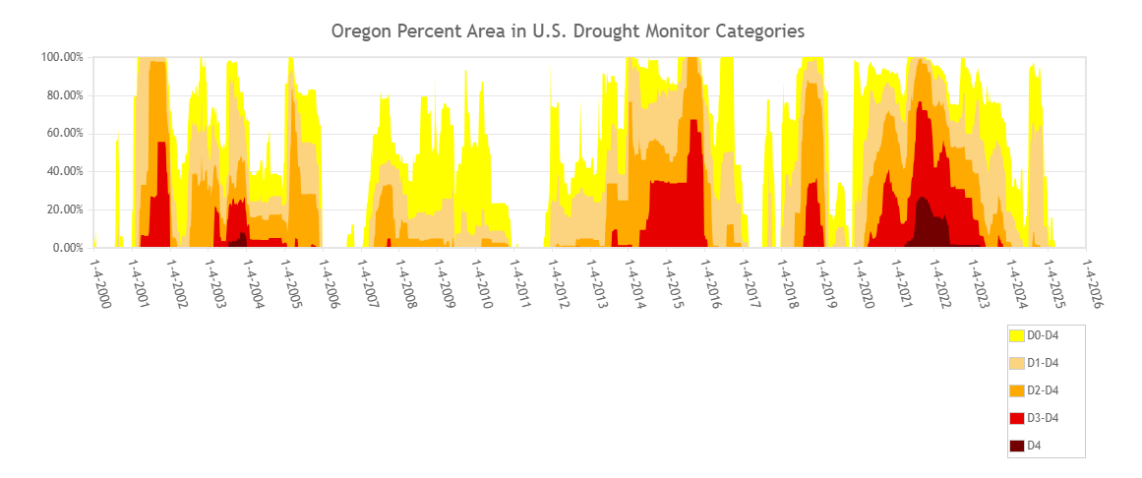
Klamath Basin Adjudication:
The Klamath Basin Adjudication is still on-going requiring numerous hours of work on behalf of the RBWUCI legal counsel to find a resolution to contested water rights issues. Now that the Adjudication process is in the court system in Klamath County it is anticipated that it is going to be a very long-drawn-out process considering then numerous parties involved in the resolution process. We anticipated that the legal fees involved to get resolution to contested water rights will continue to be extremely expensive

Maintenance:
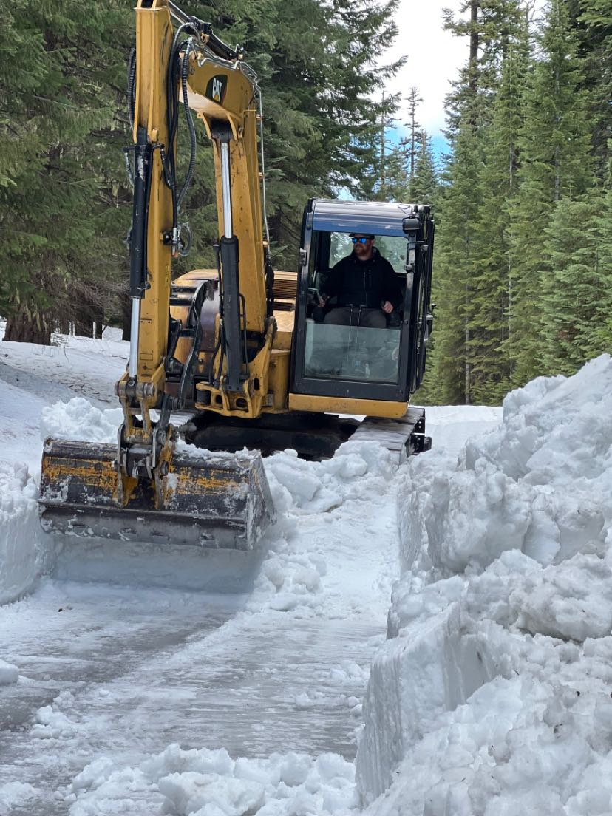
Please remember to remove all debris, obstacles, pipelines, bridges, walk boards etc., in anticipation of our equipment coming your way during maintenance season. Each year after the water has been shut off, the silt and vegetation need to be removed from the canal. MID typically puts this material back across the canal road or uses it to level the road from damage caused by human and animal traffic during the Spring. MID’s easements and rights-of-way are for district access, operation, and maintenance only. They are not public rights-of-way. Entrance onto their easements and rights-of-way may constitute trespassing on the underlying landowner’s property. MID does the mowing of the canal banks during the Fall and Spring. MID uses flail mowers that mount onto our tractors to mow blackberries and brush along our rights-of-way. We request that our water users please limit the use of the canal ditch roads during off-season. Using these roads in the off-season can cause damage to the ditch roads and makes more work for our maintenance crew. Thank you for your consideration in this matter.
Irrigation water is a valuable resource for our water
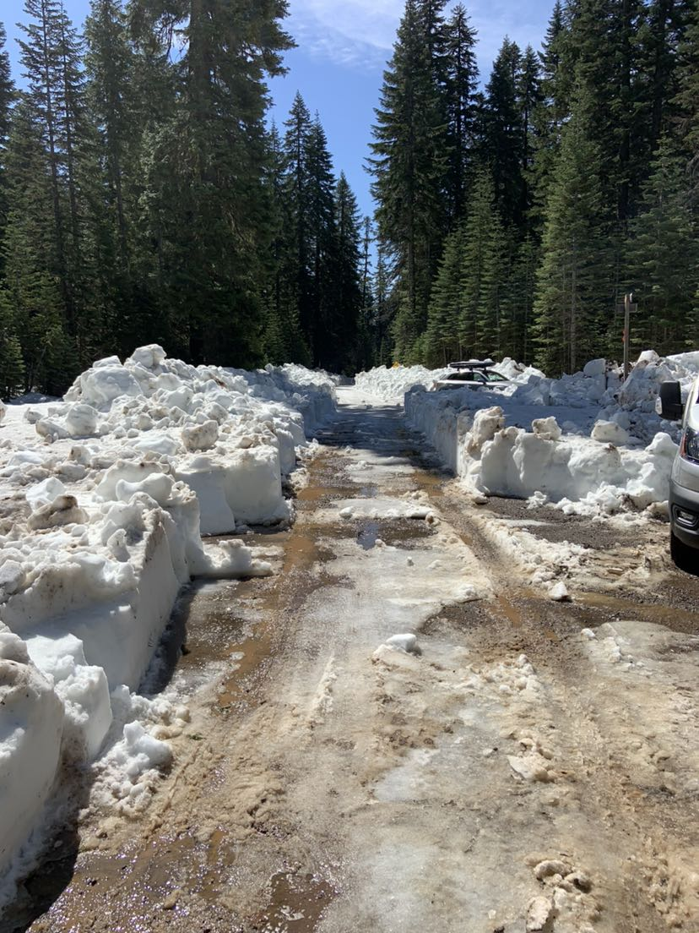
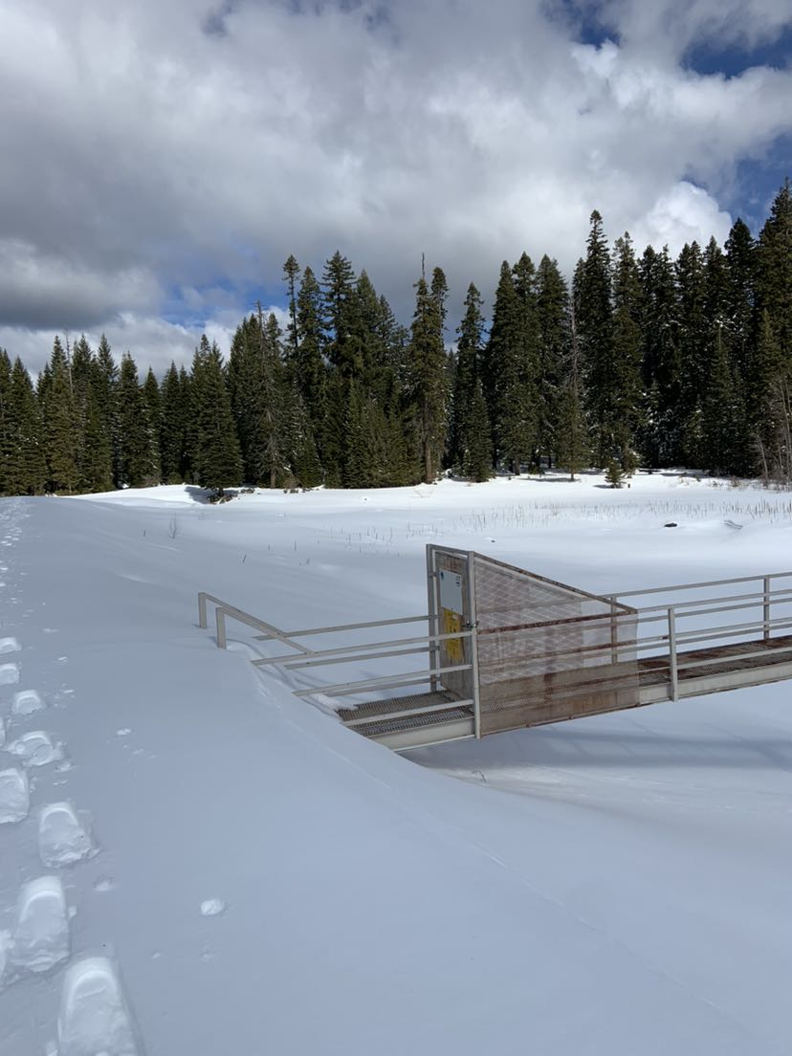
users: however, there is not an unlimited supply, nor does it work like a water faucet. Conservation, wise use, and planning the delivery of irrigation water is imperative. Medford Irrigation District’s goal is to deliver irrigation water to water users in a professional manner while maintaining control of our canals, ditches and laterals with minimal losses or damage. For M.I.D. to provide efficient service to our Patrons, we demand water user cooperation by ordering water on and off in a timely fashion as per our policy. Water orders (on, off or changed) must be placed through the office and set up on a rotation schedule per your ditch-rider.
BILLING
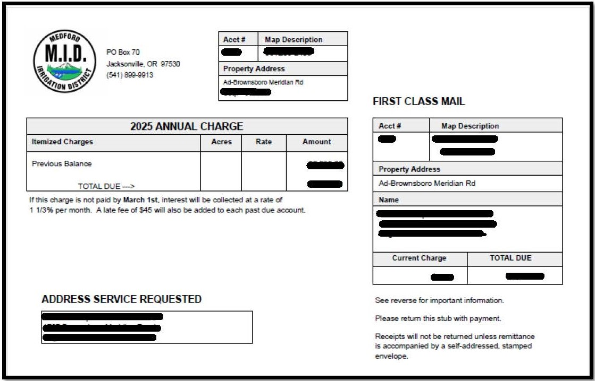
REMINDER: ASSESSMENT BILLING IS SENT ON JAN. 5, 2026, and POSTMARKED BY FEB. 28TH, 2026.
There have been updates on our financial policy. Late fees are now $50 per tax-lot, beginning March 1st, 2025. Lien fees are now $500 per tax-lot. The foreclosure process begins for those unpaid as of April 1st, 2026, on their 3rd year delinquent or balance owing 10K+.
A lien will be placed on the 2nd year unpaid bills as of April 1st, 2026.
So, if you have a balance with us that is at least 2 years old and not paid by March 1st, 2026, (including 2026 billing) you will be sent to foreclosure.
Medford Irrigation District relies on these assessments to be able to
operate and maintain our infrastructure, equipment, and staff. Thank you for your cooperation with this.
Reminder: we accept VISA, M/C, AMEX, DISCOVER and ECH on our website. Fees do apply. Credit Cards: $3 per hundred and electronic check: $2.95 flat rate. Cash and check accepted in office in person or by mail. You can pay by phone as well. Dial 877-816-9304 and follow the instructions.
Remember to sign up for our updates via email. Just go to www.medfordid.org . At the bottom of the main page, it says: “Join our mailing list”. This will keep you up to date on water issues and other district business. If there is something specific that you are looking for answers too, just give Dusk or Tammi a call and they will find the answers for you.
A WORD FROM OUR MANAGER
JACK FRIEND

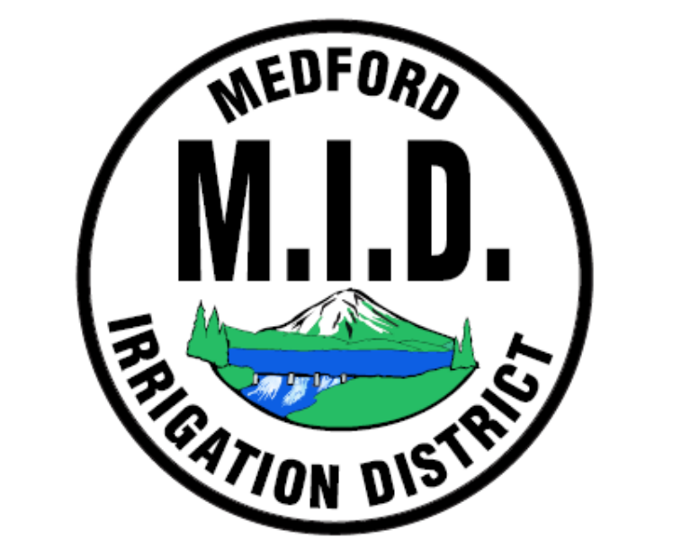
MEDFORD IRRIGATION DISTRICT
PO BOX 70
JACKSONVILLE, OR 97530

Sign up for updates on our website or
call our office and we can sign you up.

