Howard, Hyatt, Emigrant June 11, 2024

2024 2023 2022 avg

95,000

90,000

85,000

80,000

75,000

70,000

65,000

60,000

55,000

50,000

45,000

40,000

35,000

30,000

25,000

20,000

15,000

10,000

5,000


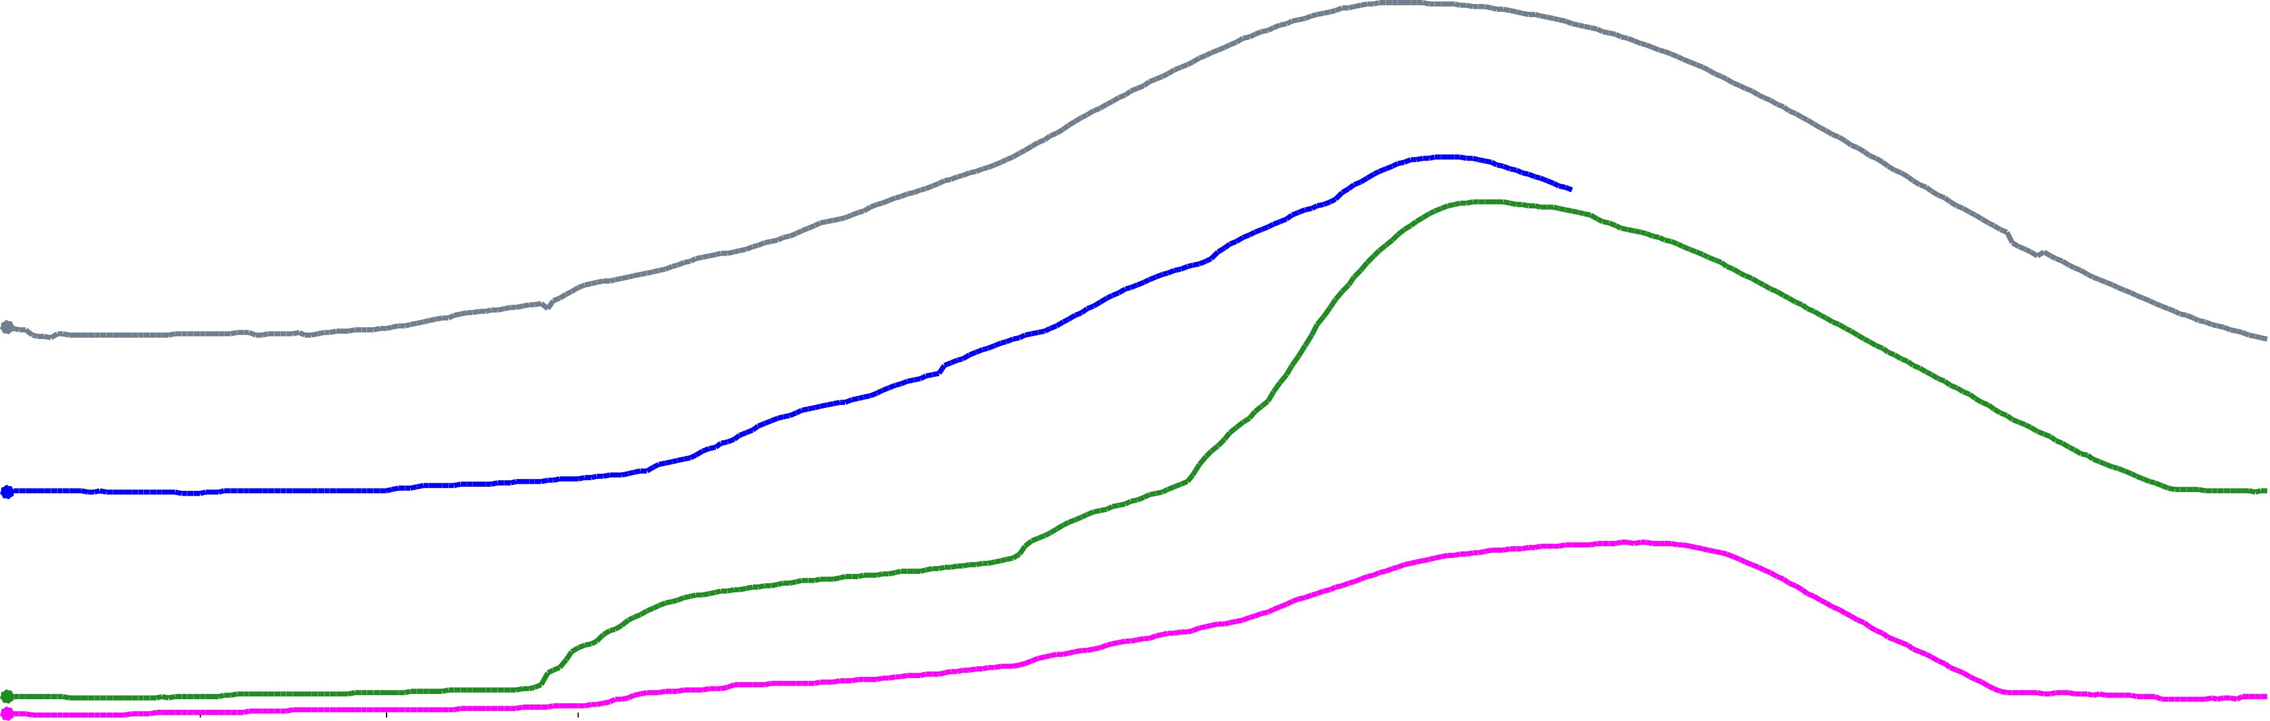
Oct 1
acre-feet
Nov 1
Dec 1
Jan 1
Feb 1
Mar 1
Apr 1
May 1
Jun 1
Jul 1
Aug 1
Sep 1

