MID NEWSLETTER
  - 2026/2027

2026/2027 HOLIDAYS  MID WILL BE CLOSED:  May 25th Memorial Day  June 19th Juneteenth  July 3rd Independence Day  Sept. 7th Labor Day  Oct. 12th Columbus Day  Nov. 26th – 27th Thanksgiving  Dec. 24th – 25th Christmas  Dec. 31st - Jan. 1st New Years  Feb. 15th Presidents Day  Staff:  Manager: Jack Friend  Office Mgr: Tammi  Office Asst: Dusk  Foreman: Jacob Young  West Side Supervisor: Dan  Maintenance Supervisor: Manuel |  | Hours of operation  MID OFFICE HOURS  APRIL thru OCTOBER  8:00 AM – 4:30 PM  NOVEMBER thru MARCH  7:30 AM – 4:00 PM  BOARD MEETINGS:  April 8th , 2026@ 5:00pm  May 13th , 2026@1:30pm  June 10th , 2026@ 1:30pm  July 8th , 2026@ 1:30pm  August 12th , 2026@1:30pm  September 9th , 2026@ 5:00pm  October 14th , 2026@ 1:30pm  November 11th , 2026@ 1:30pm  December 9th , 2026@ 1:30pm  January 13th , 2027@ 1:30pm  February 10th , 2027@ 1:30pm  March 10th , 2027@ 1:30pm | CONTACT INFORMATION  CONTACT US…  OFFICE: 541-899-9913  FAX: 541-899-9968  Website: www://medfordid.org  Email: medid@medfordid.org  Emergency Line: 541-770-0277  ___________________________  Ditch Riders:  Ride 1: Jose  Ride 2: Carlos  Ride 3: Jadd  Ride 4: Dan  Relief Riders:  Ride 1&2: Ernesto  Ride 3&4: John
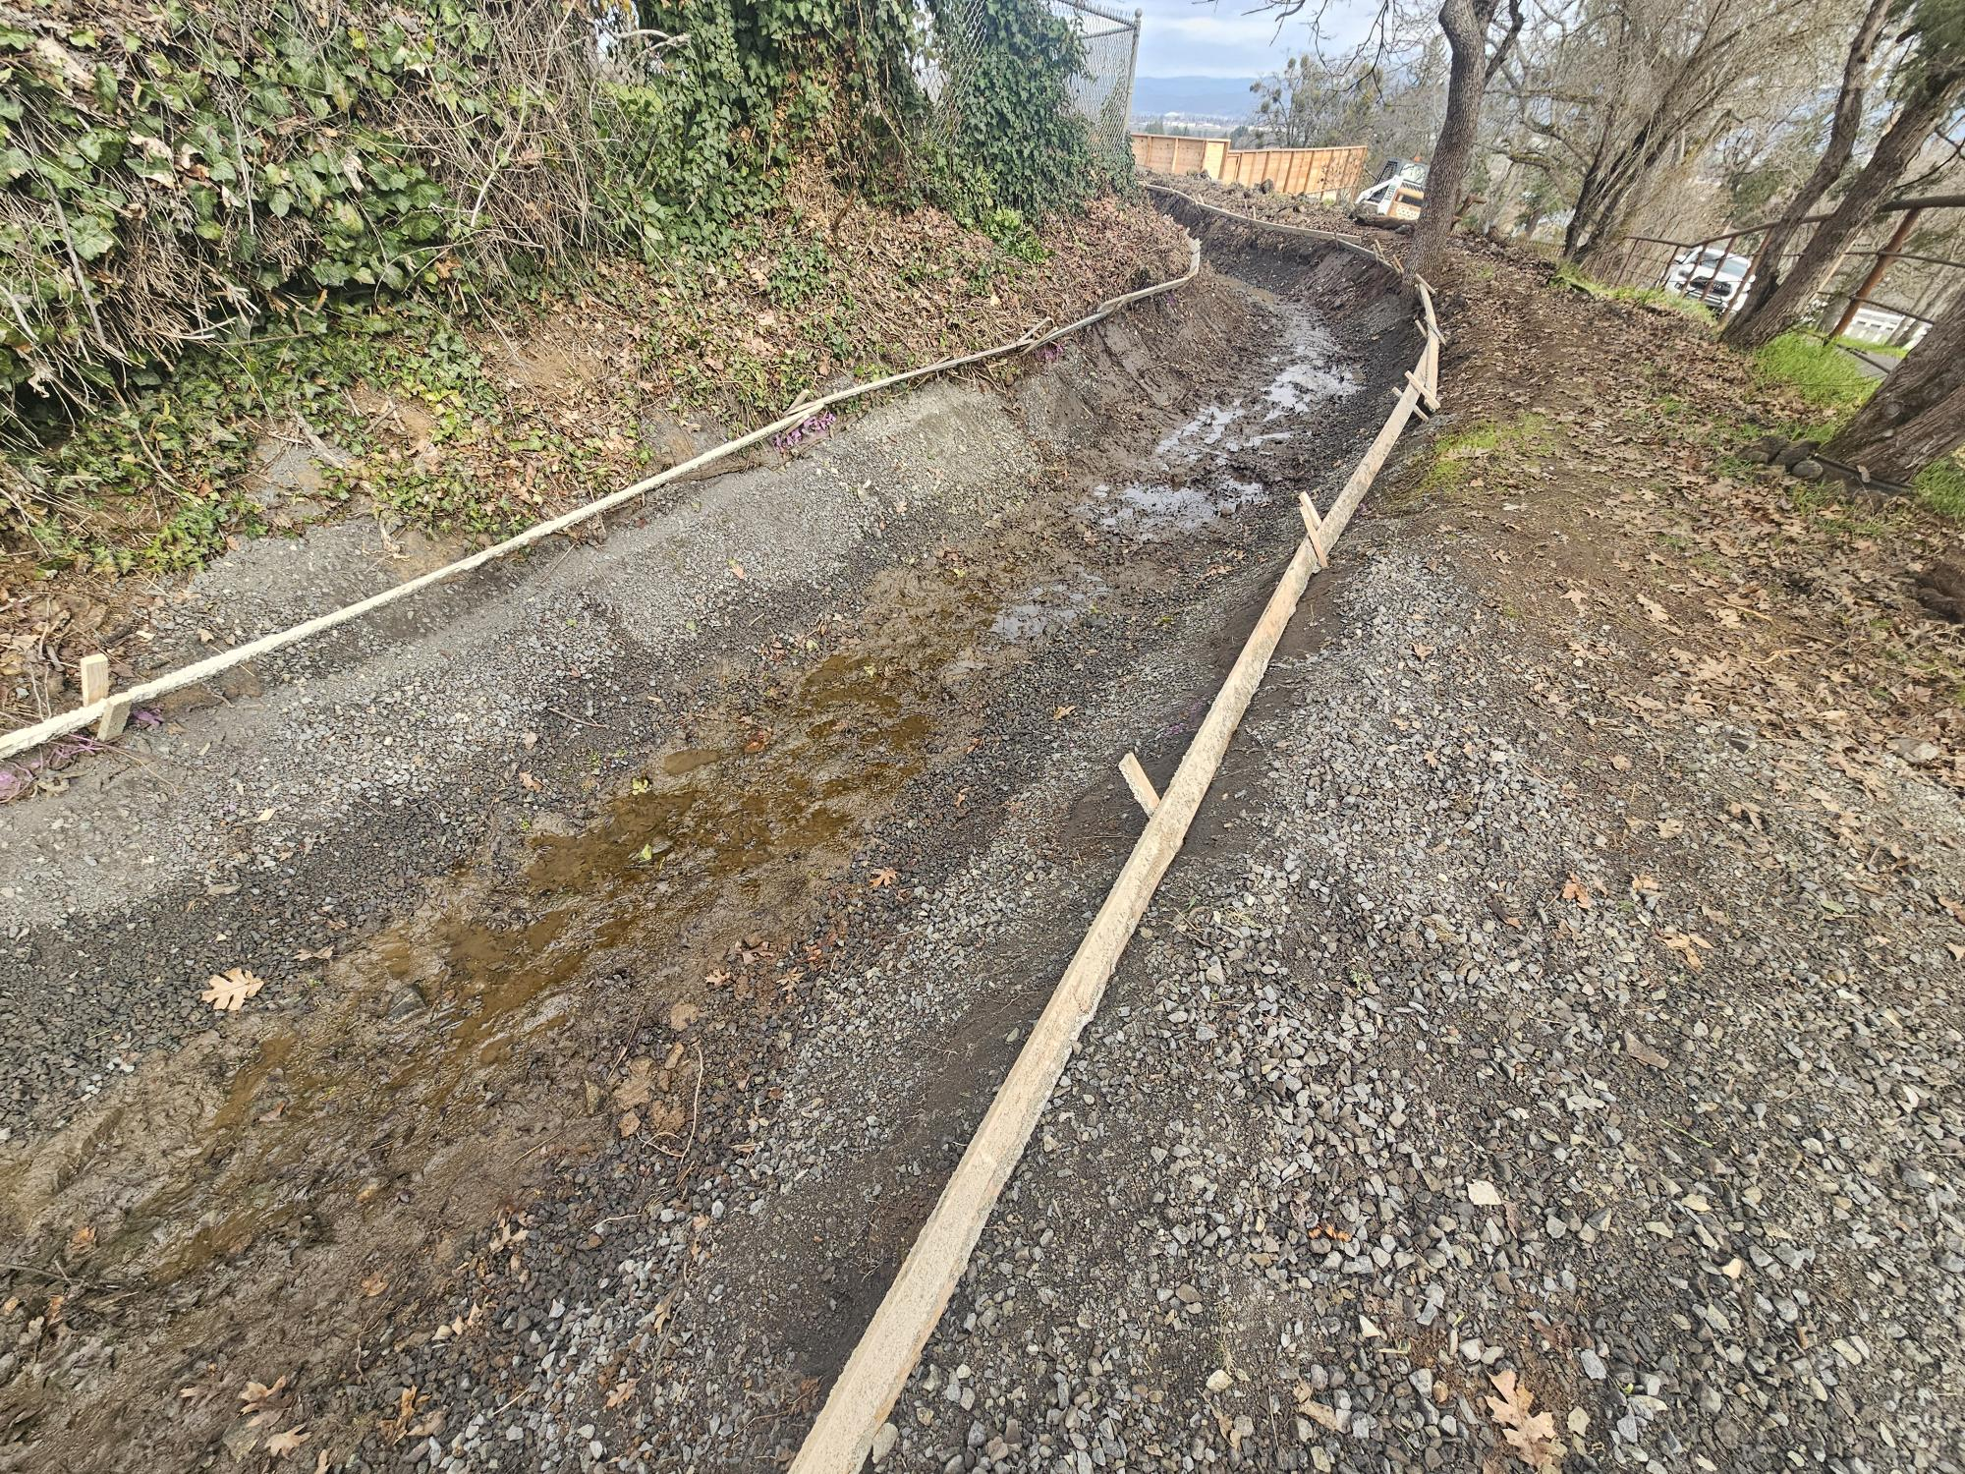  Mission Statement  To deliver water equitably and efficiently with the least amount of cost to its water users, keeping in mind the need for long-range planning and environmental impact. Through leadership, use of technical expertise, efficient operations, responsive customer service, and the creativity of people, Medford Irrigation District will seek to protect and preserve local natural and ecosystems through the effective use of water. | 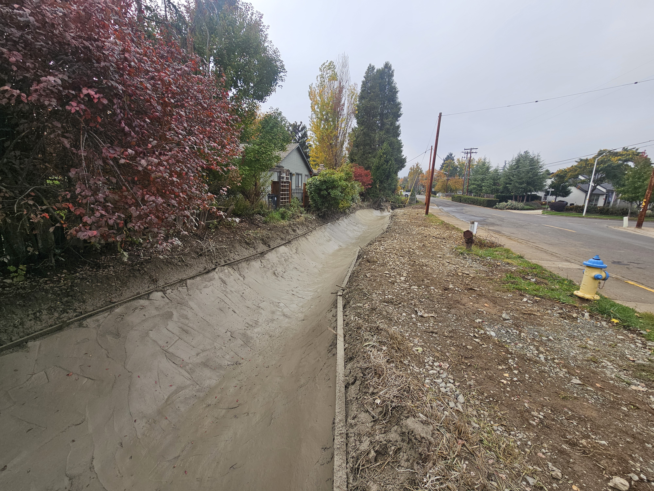 |  | 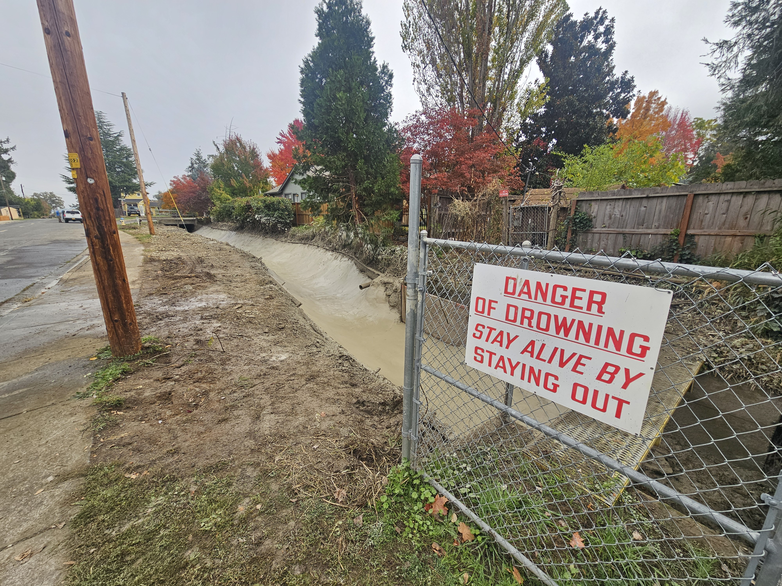
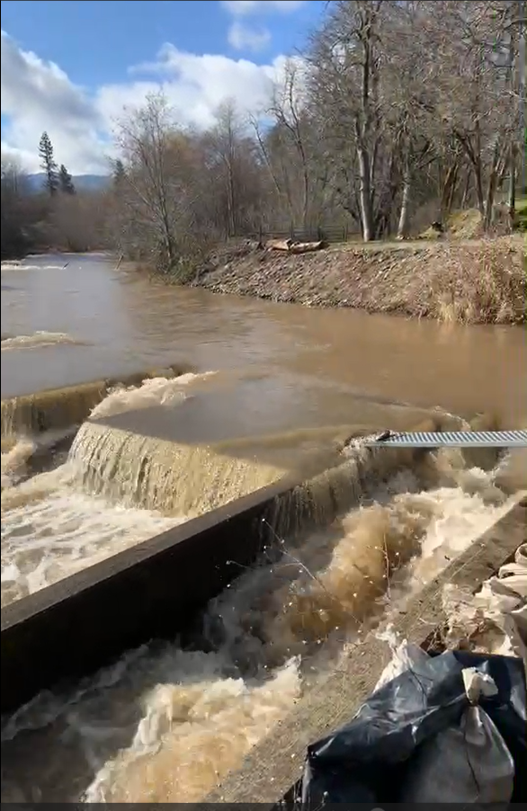
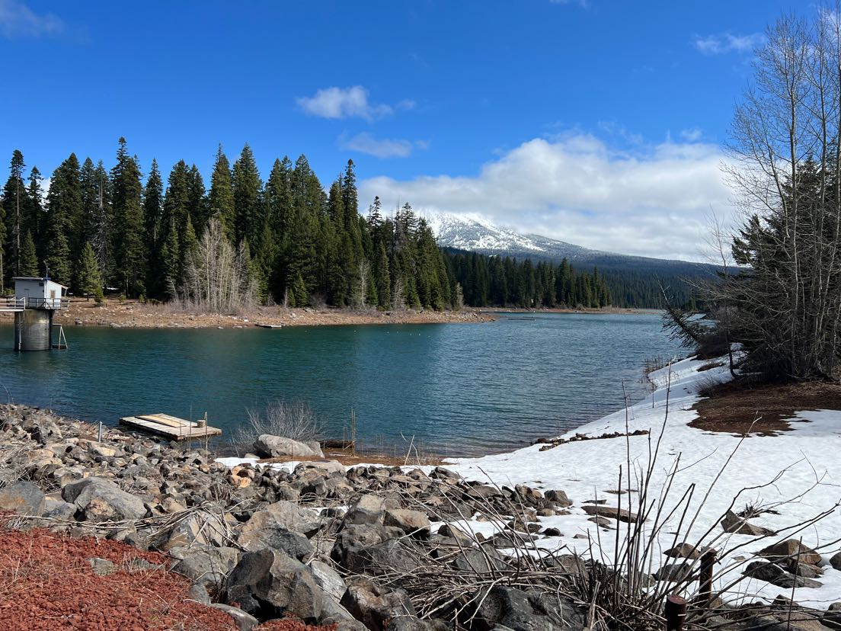
Canal Safety: Waters in the canal are non-potable and for irrigation purposes only. Do not drink, swim, bathe or otherwise contact the water. It is not recommended for pet and livestock drinking. The water is fast-moving and treacherous for humans and animals. For this reason, stay away from the canal and ALWAYS keep children, pets, and farm animals away. If you see an animal in the canal, contact the district right away. Please do not attempt to remove any animal on your own.

Report any violations that you may see on or around our infrastructure of canals, laterals, equipment, and theft of water as well. Working together will help make deliveries smoother and the availability of water for everyone.

Board of directors 2026
DIVISION 1 - Dennis O’Donoghue
EMAIL: Dennis@medfordid.org
DIVISION 2 - Sean Naumes
EMAIL: Sean@medfordid.org
DIVISION 3 - Joe DeMaggio
EMAIL: Joe@medfordid.org
DIVISION 4 - Matt Borman
EMAIL: Matt@medfordid.org
DIVISION 5 - Tom Brookins
EMAIL: Tom@medfordid.org


Important Dates to Remember:

August 28th, 2026, through Oct. 6th, 2026 @ 5pm, is the nominating petition period for a new/current board member to cast their name for the open position for their division. This year’s board seats that are up for election are: Divisions 1, 2, 3, 4, and 5.

NOTICE OF OPENINGS FOR THE BOARD OF DIRECTORS

There are 5 positions on the Board of Directors of Medford Irrigation District that will be open at the end of 2026 The open positions are for Division(s) 1, 2, 3, 4, & 5 (currently held by Dennis O’Donoghue, Sean Naumes, Joe DeMaggio, Matt Borman & Tom Brookins) to fill a full term of three years.
The new term of office will begin on 1 Jan 2027. Parties interested in running for election for either board position must file a Nominating Petition. To run for a board, position the candidate must be registered with Medford Irrigation District to vote in a division election, must be a qualified elector in the open division, and must file a valid Nominating Petition by 5:00 PM, Tuesday, October 6th, 2026, at the district office.
To inquire about qualifications and/or to pick up a Nominating Petition, please contact the MID office at 5045 Jacksonville Hwy, Central Point, Oregon 97502; telephone 541-899-9913, or our website: www.medfordid.org.

ELECTIONS
Parts of Oregon are unfortunately back in a drought.
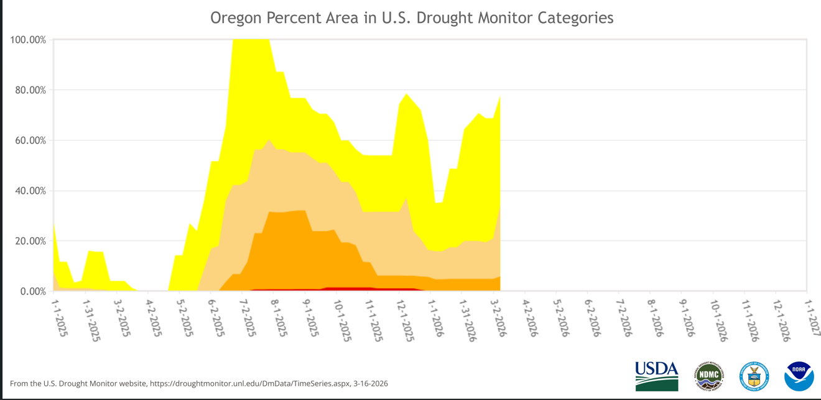

Parts of Oregon are currently in a drought. As of March 2026, the state is facing a severe "snow drought" with snowpack at only 30% of normal, leading to drought declarations in areas like Central Oregon. While conditions can vary by region, low snowpack and warm winter weather have triggered concerns for water supplies, agriculture, and high wildfire risk.
Current Drought Situation (March 2026):
Emergency Declarations: Deschutes County has declared a drought emergency due to historically low snowpack in the Central Cascades, anticipating low streamflow’s and reduced reservoir levels.
"Snow Drought" Conditions: The state is facing a severe shortage in snowpack, with levels near record lows for the state, which is vital for spring and summer water supplies.
Water Supply Concerns: The Klamath River Basin in Southern Oregon continues to face challenges from drought, affecting ranchers and tribes.
Outlook: The low snowpack and elevated temperatures mean that water supply issues are expected to continue through the spring and summer of 2026.
While some areas may experience minor improvements due to short-term rain, the overall trend is of a persistent and developing drought scenario for the state, with the region experiencing one of the worst snow droughts in its recorded history.
Maintenance:
Please remember to remove all debris, obstacles, pipelines, bridges, walk boards etc., in anticipation of our equipment coming your way during maintenance season. Each year after the water has been shut off, the silt and vegetation need to be removed from the canal. MID typically puts this material back across the canal road or uses it to level the road from damage caused by human and animal traffic during the Spring.
MID’s easements and rights-of-way are for district access, operation, and maintenance only. They are not public rights-of-way. Entrance onto their easements and rights-of-way may constitute trespassing on the underlying landowner’s property.
MID does the mowing of the canal banks during the Fall and Spring. MID uses flail mowers that mount onto our tractors to mow blackberries and brush along our rights-of-way. We request that our water users please limit the use of the canal ditch roads during off-season. Using these roads in the off-season can cause damage to the ditch roads and makes more work for our maintenance crew. Thank you for your consideration in this matter.

Irrigation water is a valuable resource for our water users: however, there is not an unlimited supply, Nor does it work like a water faucet. Conservation, wise use, and planning the delivery of irrigation water is imperative.
Medford Irrigation District’s goal is to deliver irrigation water to water users in a professional manner while maintaining control of our canals, ditches and laterals with minimal losses or damage.
For M.I.D. to provide efficient service to our Patrons, we demand water user cooperation by ordering water on and off in a timely fashion as per our policy. Water orders (on, off or changed) must be placed through the office and set up on a rotation schedule per your ditch-rider.
BILLING
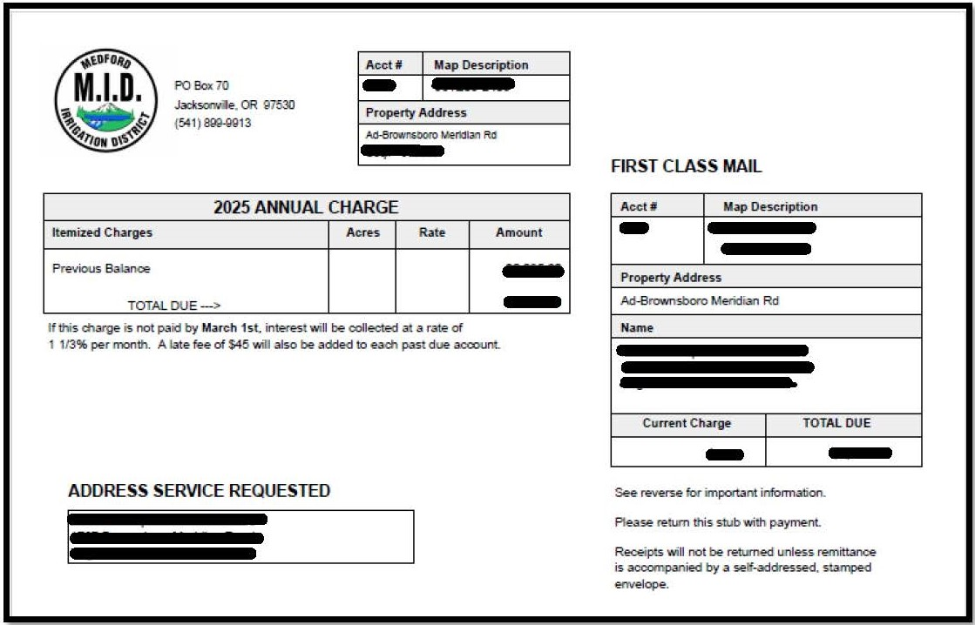
REMINDER: ASSESSMENT BILLING IS SENT ON JAN. 4, 2027, & MUST BE PAID OR POSTMARKED BY FEB. 28TH, 2027.

Late fees are $50 per tax-lot, beginning March 1st. Lien fees are $500 per tax-lot & issued April 1st. The foreclosure process begins for those unpaid as of May 1st, on their 3rd year delinquent and/or balance owing 10K+ each tax-lot.
A lien will be placed on the 2nd year unpaid on April 1st.
So, if you have a balance with us that is at least 3 years old or balance owing of 10K per tax-lot and not paid by March 1st (including current year billing) you will be sent to foreclosure.
Medford Irrigation District relies on these assessments to be able to operate and maintain our infrastructure, equipment, and staff. Thank you for your cooperation with this.

Reminder: we accept VISA, M/C, AMEX, DISCOVER and ECH on our website. Fees do apply. Credit Cards: $3 per hundred and electronic check: $2.95 flat rate. Cash and check accepted in office in person or by mail. You can pay by phone as well. Dial 877-816-9304 and follow the instructions.
Klamath Basin Adjudication:
The Klamath Basin Adjudication is still on-going requiring numerous hours of work on behalf of the RBWUCI legal counsel to find a resolution to contested water rights issues. Now that the Adjudication process is in the court system in Klamath County it is anticipated that it is going to be a very long-drawn-out process considering then numerous parties involved in the resolution process. We anticipated that the legal fees involved to get resolution to contested water rights will continue to be extremely expensive.

Improvement Projects
Joint System Phase 1 Project
- The Categorical Exclusion (CATEX) environmental approval from EPA remains pending.
- No major issues are expected, but final signature is awaiting federal review.
- Staff have begun working on amendments to convert the project award into a construction loan.
- Additional funding options through the DEQ Clean Water State Revolving Fund remain available if needed.
Floating Solar Project
Construction continues at the MID pond.
- Ribbon cutting is tentatively planned for May 8, though it may be postponed depending on construction progress.
- Electrical transformer equipment has already been delivered.
- Minor supply chain delays have occurred with specialty electrical connectors.
Regional officials and potentially the Governor’s office have expressed interest in attending the ribbon-cutting event.
Medford Canal Project
- The district has submitted a Community Project Funding request (earmark request) to Senators Wyden and Merkley.
- Letters of support were received from several regional organizations.
- The district will proceed with design work related to the OWEB grant agreement.
Watershed Plan EIS
- Draft documents available for board review.
- Board feedback requested soon.

Remember to sign up for our updates via email. Just go to www.medfordid.org .
At the bottom of the main page, it says: “Join our mailing list”. This will keep you up to date on water issues and other district business. If there is something specific that you are looking for answers too, just give Dusk or Tammi a call and they will find the answers for you.
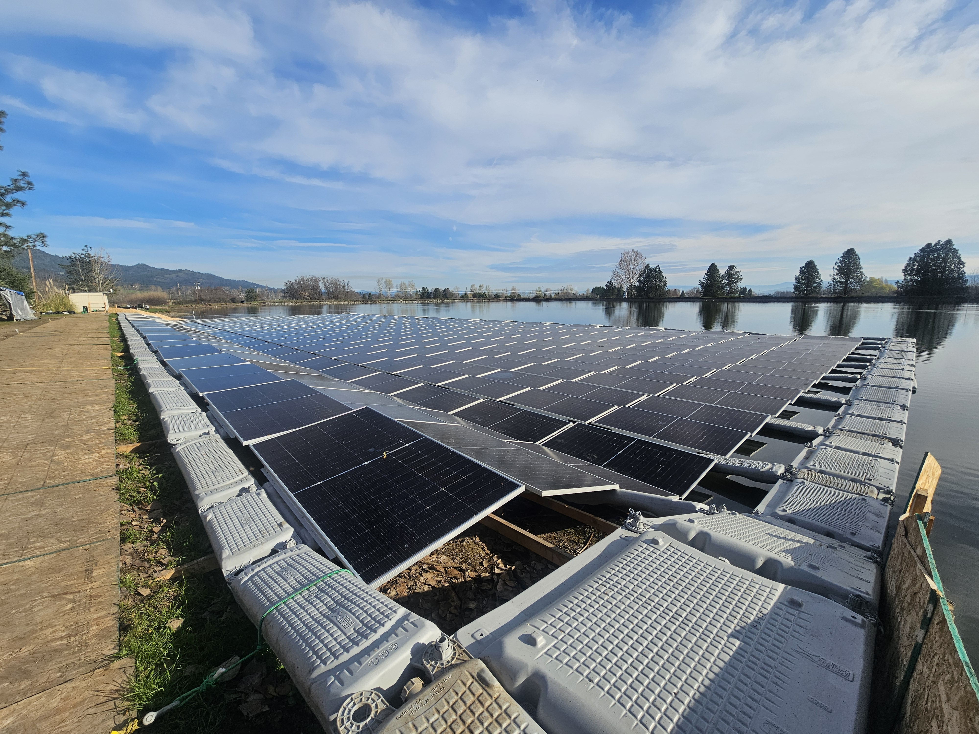
MID Solar Project

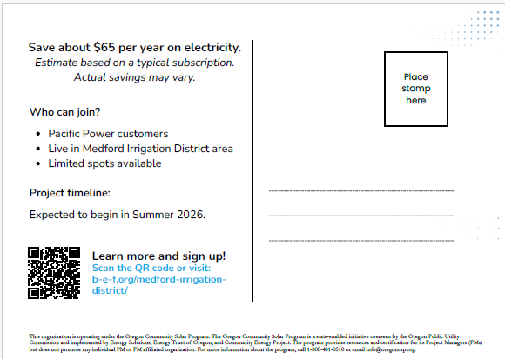


ALL INQUIRIES PLEASE CALL----1-800-481-0510

